Unsoundness and Blemishes of the Feet
The old adage, "No foot, no horse," has much merit. As a major shock-absorbing mechanism, the feet are subjected to great stress. Horses that work hard most of their lives may acquire one or more unsoundnesses of the feet to varying degrees as they get older. Wide, deep heels, dense horn, combined with proper care and shoeing, will reduce the chances that these conditions will develop.

Sidebones This is a common unsoundness resulting from wear, injury or abuse. On each side of the heel extending above the hoof are elastic cartilages just under the skin that serve as part of the shock-absorbing mechanism. They are commonly termed lateral cartilages. When they ossify (turn to bone) they are called sidebones. In the process of ossification they may be firm but movable inward and outward by the fingers. The horse is then considered "hard at the heels." Sidebones are more common to the front outside lateral cartilage than to other locations.

Ringbone Ringbones are not very common but are serious unsoundnesses. These bony deposits usually appear just above the coronary band (hoof head) on a hind foot, although front feet also may be affected. The long and short pastern bones may fuse together, causing severe pain and lameness.

Founder (Laminitis) is an inflammation of the sensitive laminae which attach the hoof to the fleshy portion of the foot. Its cause is probably a sensitization (allergy). When horses gain access to unlimited amounts of grain, founder often results. Other conditions conducive to founder are retained placenta after foaling and sometimes lush grass. All feet may be affected, but front feet usually suffer the most. Permanent damage usually can be reduced or eliminated by immediate attention by a competent veterinarian. Permanent damage results from dropping of the hoof sole and upturn of the toe walls when treatment is neglected.

Navicular Disease is an inflammation of navicular bone and bursa. The condition causes lingering lameness and should be diagnosed and treated by a veterinarian.

Corns appear as reddish spots in the horny sole, usually on the inside of the front feet, near the bars. Advanced cases may ulcerate and cause severe lameness. There are many causes, but bruises, improper shoeing and contracted feet are the most common. Response to correct treatment and shoeing is usually satisfactory.

Hoof cracks When hoof cracks extend upward to or near the hairline, lameness often results. When well established, the condition is difficult to arrest and cure. It can be prevented in most hooves by proper trimming and shoeing before it becomes serious.

Contracted feet are a result of continued improper shoeing, prolonged lameness or excessive dryness, where the heels lose their ability to contract and expand when the horse is in motion. Horses kept shod, those with long feet and those with narrow heels are susceptible to the condition. Close trimming, going barefooted or corrective shoeing usually produces sufficient cure to restore the horse to service.

Underrun heels often occurs along side contracted feet. They are caused by chronic shoeing at inappropriate angles. This impacts the biomechanics of the hoof and can lead to lameness if not addressed properly.

Thrush is a filth disease enhanced by decomposition of stable manure around the bars and frog of the foot. It may cause lameness. Response to cleanliness and treatment is usually prompt and complete.

Scratches or grease heel is characterized by inflammation and scab formation on the back surfaces of the fetlocks. Prevent as for thrush.

Club foot In the genetic club footed horse, the cannon bone of the clubby foot is slightly shorter and so too is the tendon shorter than the normal leg. Thus the heel will always be taller and the toe will always be shorter than the normal leg. If managed properly, the horse will be sound but will have an uneven gait because the clubbed foot tracks slightly shorter. If not managed correctly, this deformity can lead to chronic lameness.

Unsoundnesses and blemishes of the front legs

Pointing
The front legs bear about 60 percent of the weight of a horse. Healthy horses stand at rest with weight equally distributed on both front legs. Lameness in the foot or leg will cause "pointing." Pointing refers to a state of rest with one foot positioned about 10 to 12 inches ahead of the other in an effort to reduce weight on the affected side.
Weight is shifted habitually from one hind limb to the other by healthy horses during rest and does not indicate lameness.

Splints are bony deposits that appear on the upper inside border of the front cannon. They seldom cause lameness, but occasionally a "high" splint may interfere with the action of the knee and cause unsoundness. Young horses stressed by play or training may "blow" a splint. If lameness persists more than a few days, a veterinarian should treat splints.

Wind or road puffs
Small swellings around the ankles and lower cannons are common to horses that are used heavily or trailered a lot, or to older animals. Those with adequate flat bone, well-defined joints and prominent veins usually have sufficient substance and circulation to withstand wear better than horses with coarse, round bone and meaty legs with poorly defined joints and veins. Puffs are blemishes.

Capped elbow or "shoe boil" is a blemish at the point of the elbow. It is usually caused by injury from the shoe when the front leg is folded under the body while the horse is lying down. Shoes with calks (heels) cause more damage than plates.

Bowed tendons are apparent by a thickening of the back surface of the leg immediately above the fetlock. One or more tendons and ligaments may be affected, but those commonly involved are the superflexor tendon, deep flexor tendon and suspensory ligament of one or both front legs, although they can also affect one or both hind legs. Predisposing causes are severe strain, wear and tear with age and relatively small tendons attached to light, round bone. Bowed tendons usually cause severe unsoundness.

Unsoundnesses and blemishes of the hind legs
The hock is the most vulnerable, therefore the most important, joint of the body. All of the power of a pulling horse is generated in the hindquarters and transmitted to the collar by contact with the ground via the hocks. Working stock horses must bear most of the weight on the hind legs by keeping their hocks well under them, if they are to attain maximum flexibility. Degree of finesse is determined with gaited and parade horses by how well they "move" off their hocks.
Structurally sound hocks should be reasonably deep from top to bottom, well supported by fairly large, flat, straight bone, be characterized by clean-cut, well-defined ligaments, tendons and veins, and should be free from induced unsoundnesses and blemishes.

Bone spavin or jack spavin
Bone spavins are common unsoundnesses of light horses, especially those with sickle hocks or shallow hock joints from top to bottom surmounting fine, round bone. Such conformation should be seriously faulted in a working stock horse.
A bony enlargement at the base and inside back border of the hock may be a bone spavin. Inspect the horse by bending or squatting in front of it and looking between the front legs at the face of the hocks, or by standing near a front leg and looking under the belly at the opposite hock. Before passing judgment, assume the same position and look at the opposite hock. If they are both alike, the horse is probably normal. In the early stages, lameness may be apparent only when the horse has remained standing for a while. Bone spavins, like ringbones, may fuse bones and render joints inarticulate.

Bog spavin
Bog spavins are soft swellings on the inside-front area of the hocks that may result from the presence of synovial fluid ("joint oil"). Blemishes of this type are more common to heavy horses than light ones, although individuals of low quality are susceptible to the condition.

Thoroughpin
Thoroughpins are blemishes that appear as soft swellings above and back of the hock joint just in front of the large tendon. They can be pressed from side to side, hence the name.

Curbs
Curbs can be seen best from a side view. They appear as swellings on the back border of the base of the hock. They result from inflammation and thickening of the sheath of one of the important tendons. Shallow, sickle hocks predispose to development of curbs. They may or may not cause lameness.

Capped hock
A thickening of the skin or large callus at the point of the hock is a common blemish. Many capped hocks result from bumping the hocks when trailering in short trailers or with unpadded tail gates.

Stringhalt or crampiness of the hind leg(s), is a disease of the nervous system resulting in spasmodic flexion of one or both hocks when the horse is first moved after standing or when caused to back. The hock is raised abnormally high. It occurs more frequently in older animals and may not render the animal unserviceable.

Stifled
When the patella of the stifle joint is displaced, the animal is stifled. If the patella is displaced outward, severe lameness results. If it is displaced inward, lameness is less serious and sudden movement may replace it. However, the condition is likely to recur frequently.

Cocked-ankles
Cocked-ankles may appear in front but are more common in hind legs. Severe strain or usage may result in inflammation or shortening of the tendons and a subsequent forward position of the ankle joints. Advanced cases impair movement and decrease usefulness.
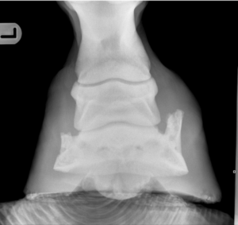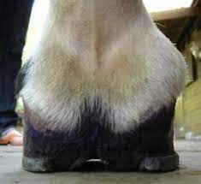 | 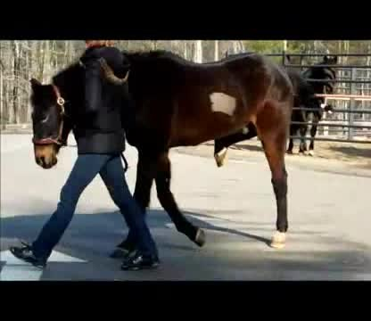
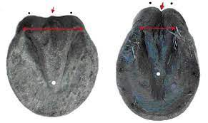 | 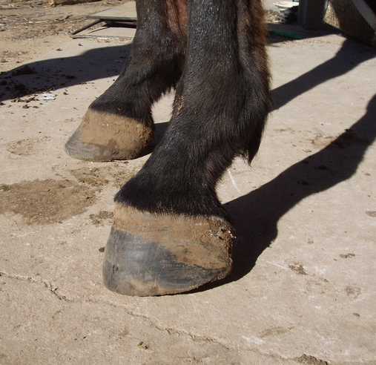
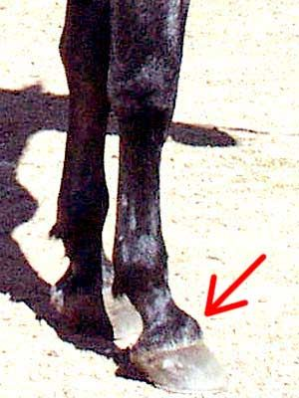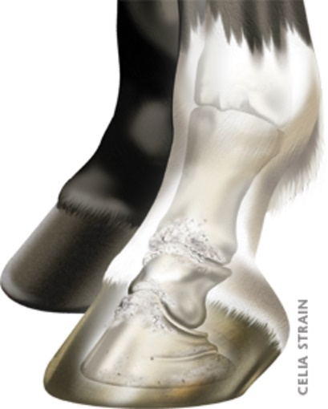 | 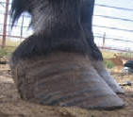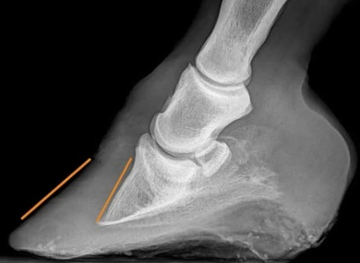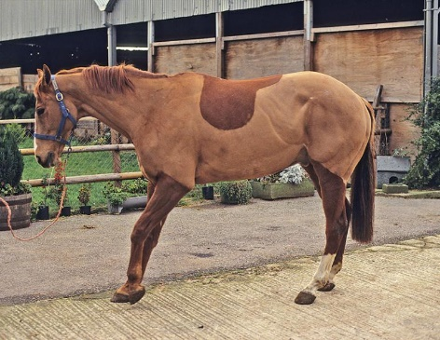
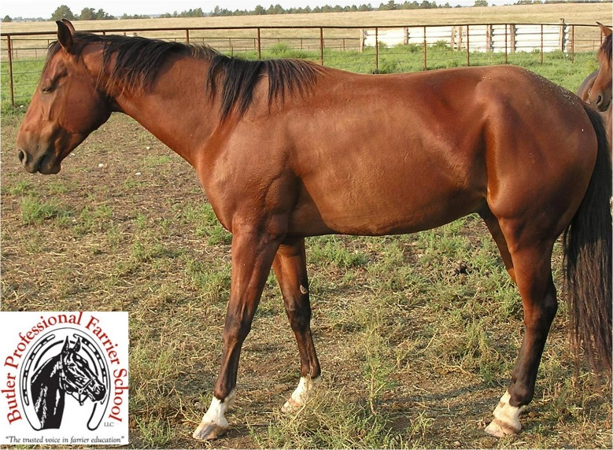 | 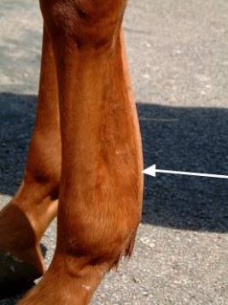
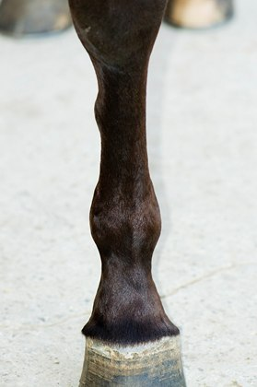 | 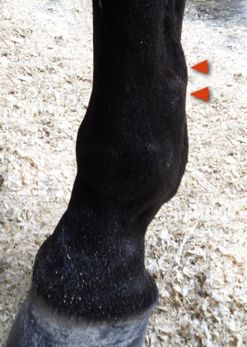
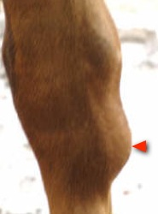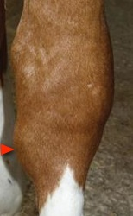 | 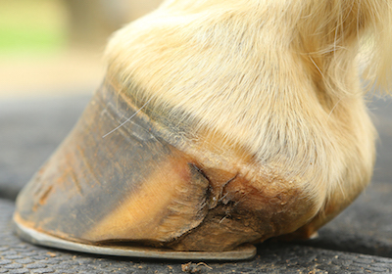
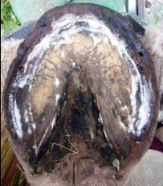 | 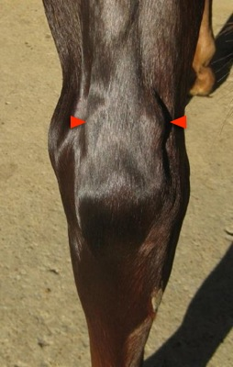
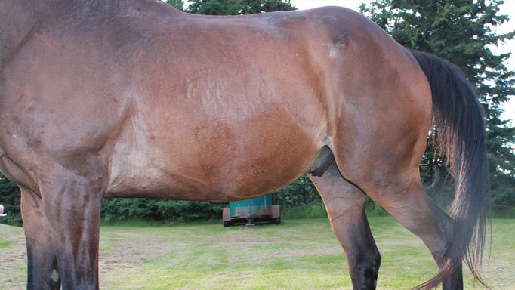 | 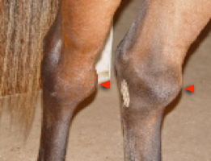
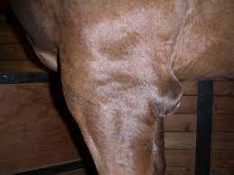
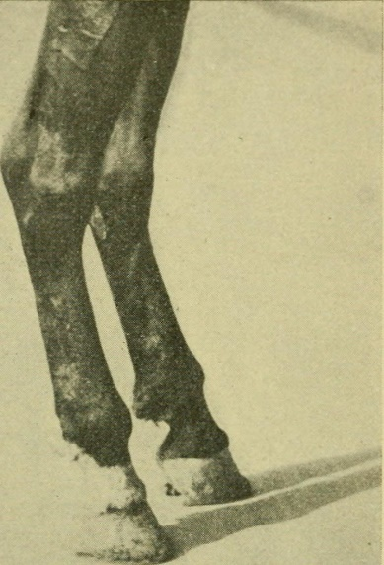 | 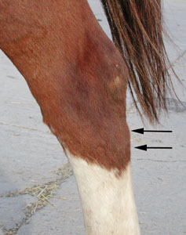
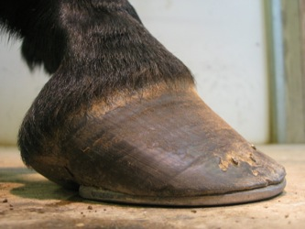 | 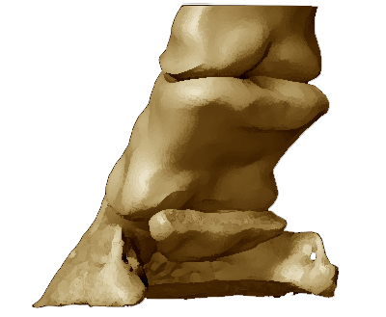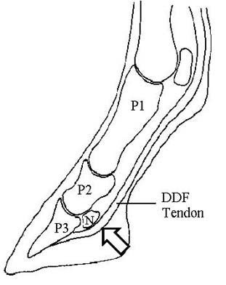
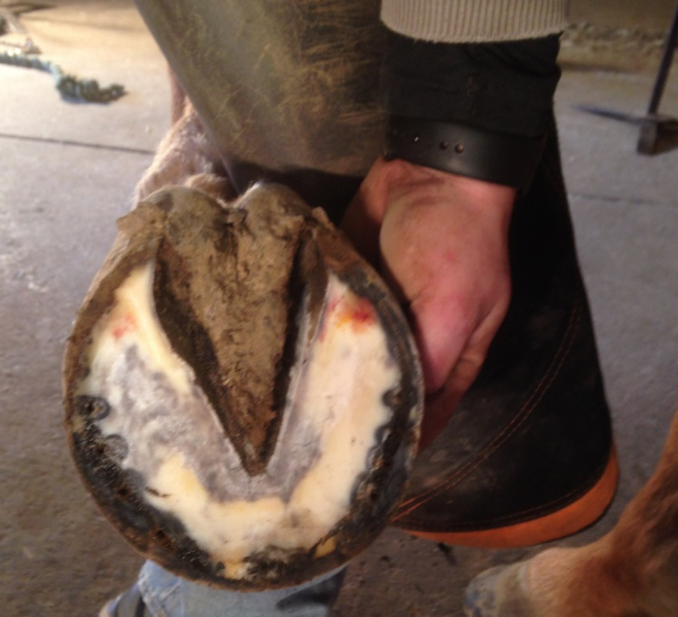 | 