Topic | Travel Safety
D1 | Name basic rules of safe riding in a group in an enclosed area.
D2 | Name 2 pieces of equipment used on your mount for its safety in a trailer.
D3 | Name rules for riding safely on public roads in your state. Describe the procedure for a mounted group crossing a public roadway. Describe the proper steps to load/unload a mount.
C1 | Name basic equipment needed for mount’s safety and comfort during trailer travel. Name 2 documents you should carry if traveling long distances or out of state. Discuss 5 items from the truck/trailer safety checklist that you should check before you travel.
C2 | Demonstrate how to load/unload an experienced, cooperative mount (with assistance). Name which equine health certificates/documents are required to travel in your state.
HB | Review the vehicle/trailer checklist. Discuss how to prepare a mount for hauling both short and long distances.
HA | Discuss diseases associated with travel or exposure to strange mounts.

Name: __________________________
- Cross out the tips that are not correct when riding in a group in an arena.
- Pass left shoulder to left shoulder when going in opposite directions like driving a car.
- Keep as far apart as possible.
- Keep at least 1-2 horse lengths apart.
- Jumping horses always have the right of way
- Longeing a horse is OK to do in the same space as someone riding.
- Allow your horse to stop at the gate whenever he needs a break.
- Dismount in the center of the arena.
- Dismount at the arena gate.
- If cooling your horse out or walking to give your horse a break, walk along the rail (perimeter).
- If cooling your horse out or walking to give your horse a break, walk to the inside of the arena.
- Its OK to pass a horse that is going slower than yours as long as you don’t pass too closely.
- Its OK to circle or cross the arena if needed to give more space between you and other riders.

- Put these 13 steps to load a horse in a horse trailer in the proper order.
___Secure trailer windows and vents for how you intend to travel.
___Put up the butt-bar (if straight load) or secure the body-bar (if slant load).
___Verify that you have your horse’s current Coggins, vaccination records, and health certificate in the vehicle.
___Open the horse trailer doors and ramp (if your trailer has one).
___Tie the horse in the trailer using a quick-release knot.
___Place bedding and hay in the horse trailer to prepare the horse’s space for travel.
___Perform a truck and trailer safety inspection.
___Hook up trailer to the hauling vehicle.
___Check break lights, running lights, and turn signals on the trailer.
___Load any tack, equipment, extra feed, and extra bedding into the truck and trailer.
___Lead the horse onto the trailer.
___Put protective equipment on horse.
___Shut the trailer doors.

- Put these 7 steps to unload a horse from a horse trailer in the proper order.
___Clean manure out of the trailer.
___Drop the butt-bar (if straight load) or move the body-bar out of the way (if slant load).
___Remove protective equipment from horse.
___Lead or back the horse out of the trailer.
___Untie the horse from the trailer.
___Open the trailer doors and ramp (if your trailer has one).
___Shut the windows and vents.

- What items should be checked when performing a truck & trailer pre-trip safety inspection?

- Color the parts of the horse that the equipment below protects?
  - Head Bumper (red)
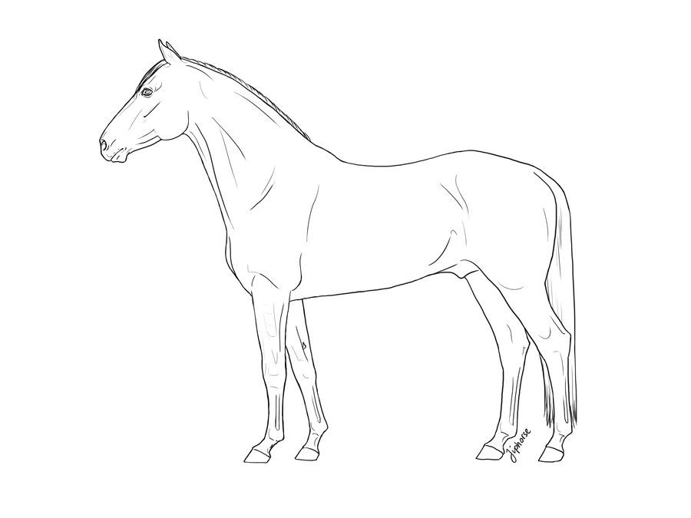
  - Right Hind Bell Boot (orange)
  - Shipping Blanket (yellow)
  - Right Front Shipping Boot (green)
  - Left Hind Shipping Boot (blue)
  - Tail Bandage (purple)
  - Fleece Shipping Halter (pink)
  - Right Hind Stable Bandage (brown)
  - Left Front Shipping Bandage (grey)

