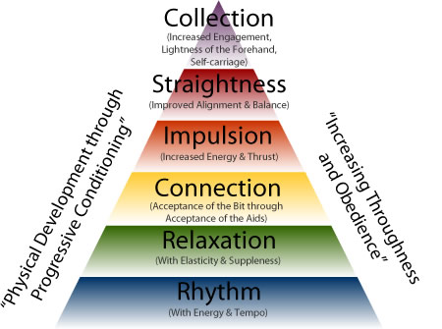

Training Pyramid

Rhythm (with energy and tempo): The regularity of beats in a gait. The walk is 4-beat, the trot is 2-beat, the canter is 3-beat. This is different from tempo or cadence which refers more to the speed of footfalls. Through proper training, the natural footfalls of the horse are preserved. Even an untrained horse will have correct natural rhythm to his gaits, and its up to us as riders and trainers not to mess with their natural rhythm.

Relaxation (with elasticity and suppleness): This has to do with the horse’s acceptance of the rider. His ability to respond to aids without tension. Part of relaxation is elasticity (ability to lengthen and shorten strides willingly) and another part of relaxation is suppleness (ability to bend/give). Correct training should not progress until the horse demonstrates relaxation.

Connection (acceptance of the bit through acceptance of the aids): Maintaining good contact with the bit, by driving the horse from the hindquarters in a way that the horse seeks the contact and the rider encourages this contact by having steady hands and relaxed, elastic elbows. As a result of this contact and relaxation from the horse, you will establish connection. Sometimes this is called “being on the bit” and is correct when the horse’s poll is the highest point of their body, and their nose is just slightly in front of the vertical. You should never just use the reins to create a “headset” for the horse. This will cause tension and relaxation cannot be achieved.

Impulsion (increased energy and thrust): The hindquarters of the horse becomes engaged, and the horse carries more of his weight on his back legs. The back legs reach up underneath the belly and are able to give more energy and power to his movement. This is sometimes referred to as being forward. (This does not mean a faster tempo, but it will often result in a longer stride or more energy in their stride.) Correct muscle development is important for impulsion. The hindquarters can be strengthened by lateral work, half halts, and transitions. Again relaxation is important because tension will block impulsion.

Straightness (improved alignment and balance): Horses are naturally crooked. Just like people are usually right or left handed so are horses. Horses tend to have one direction that is more stiff or difficult for them than another. Straightness is important because if one side of the horse is allowed to develop more than another this can cause balance and even lameness issues later on. Straightness comes from aligning the horse’s shoulders with his hind end. While straightness is being constantly developed, before true straightness can be achieved, the horse must be moving forward with impulsion. (Think of riding your bike. If you are going slow it’s hard to keep your bike from wobbling side to side, but if you are moving forward with energy, keeping your bike straight is easy.)

Collection (increased engagement, lightness of the forehand, and self-carriage): Collection is achieved when the horses weight is shifted to his hind end. His hindquarters become engaged and his forehand is lifted. His weight and the weight of the rider is more evenly distributed across all four legs. Collection is only achieved through proper, systematic training. As training progresses collection improves, so does the horse’s balance and self-carriage. Impulsion and collection are connected. You cannot have correct collection without the energy coming from the hindquarters. Collection allows the gaits to be more elegant and expressive and will help maintain the horse’s soundness.

Throughout proper training, there is physical development through progressive conditioning and increasing thoroughness and obedience.

