Toxic Plants
To create flash cards, print out and fold in the middle of the paper. Laminate if possible and cut out each card.

Red maple trees (Acer rubrum)  ID: A medium-sized tree with leaves that are green in the spring and summer, with shallow notches, bright red stems and a whitish underside; in fall, the leaves turn bright red. The bark is smooth and pale gray on young trees, and becomes dark and broken on older trees.  Range: The native range is eastern North America, from Canada to Florida and west to Minnesota and eastern Texas, but ornamental specimens have been planted all over the country.  The danger: Ingestion of fresh, growing red maple leaves seems to do little or no harm, but when the leaves wilt they become extremely toxic to horses. Access to wilted leaves is most common after storms, which may cause branches to fall into pastures, or in the autumn when the leaves fall and are blown into grazing areas. The toxins in wilted red maple leaves cause the red blood cells to break down so that the blood can no longer carry oxygen; the kidneys, liver and other organs may also be damaged. As little as a pound or two of leaves can be fatal.  Signs: Depending on how many leaves were eaten, signs can appear within a few hours or as long as four or five days after consumption. Signs include lethargy; refusal to eat; dark red-brown or black urine; pale yellowish gums and mucous membranes at first, advancing to dark muddy brown; increased respiratory rate; rapid heart rate; dehydration.  What to do: The only treatment is the administration of large amounts of intravenous fluids and possibly blood transfusions. Recovery depends on how many leaves were consumed and how promptly the horse receives care. (Read about one horse's recovery in Red Maple Leaf Poisoning Scare.)  Special note: Research indicates that the leaves of at least two related species--the silver and sugar maples--may contain the same toxic elements as red maples, but in less toxic amounts. | 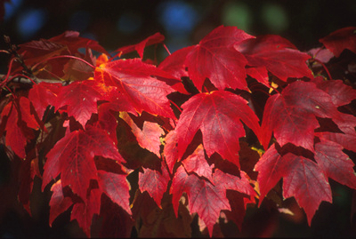
Oleander (Nerium oleander)  Also known as: Rose laurel, adelfa, rosenlorbeer  ID: An evergreen shrub that can reach the size of a small tree, oleander has elongated, thick leathery leaves that can grow to three to 10 inches long. The flowers, which grow in large clusters at the end of branches, are one to three inches in diameter and can be white, pink or red.  Range: Hardy only in hot climates, oleander is used extensively in landscaping across the southern United States, from California to Florida. It is also grown as a potted plant in northern areas.  The danger: All parts of the plant contain the toxins oleandrin and neriin, which disrupt the beating of the heart. The leaves remain toxic when dried. About 30 to 40 leaves can be deadly to a horse.  Signs: Effects are usually seen several hours after ingestion and last over 24 hours. Signs include colic, difficulty breathing, tremors, recumbency and an irregular heart rate. The pulse may be either slowed or accelerated.  What to do: Horses can survive if treated early with supportive care, such as the administration of activated charcoal to inhibit further toxin absorption and the use of anti-arrhythmic drugs to stabilize the heart. | 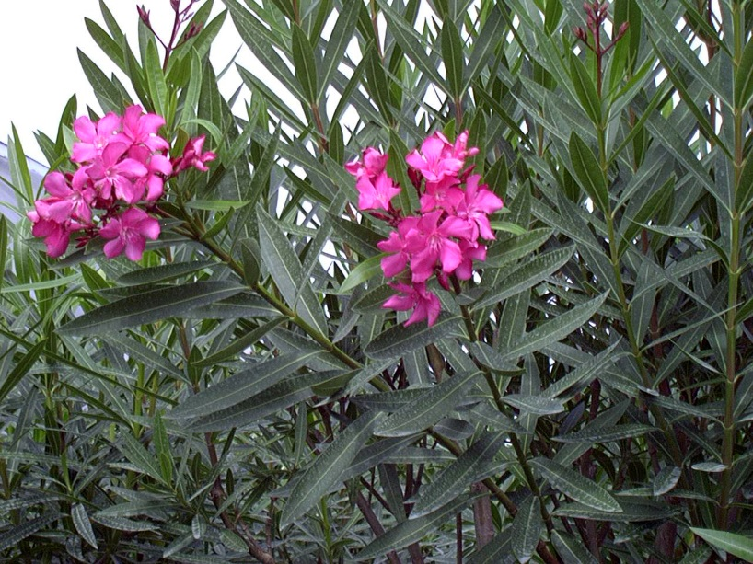
Bracken fern (Pteridum aquilinum)  Also known as: brake fern, eagle fern  ID: A perennial fern with triangular leaves that can reach two to three feet high. Grows in clumps in woodlands and moist open areas.  Range: Coast to coast, except for the Mediterranean and desert climates of Southern California and the Southwest.  The danger: Bracken fern contains thiaminase, which inhibits absorption of thiamin, which is vitamin B1. Thiamin is necessary to nerve function, and deficiencies can lead to neurological impairment. The relative toxicity of individual leaves is low--horses must consume hundreds of pounds to experience ill effects. However, bracken fern is unique among the toxic plants in that some horses seem to develop a taste for it and will seek it out even when other forages are available.  Signs: Signs are related to neural dysfunctions resulting from vitamin B1 deficiency and can include depression, incoordination and blindness.  What to do: Large doses of thiamin over the course of a week or two can aid in the recovery of horses whose bracken consumption is discovered before the neurological signs are severe. | 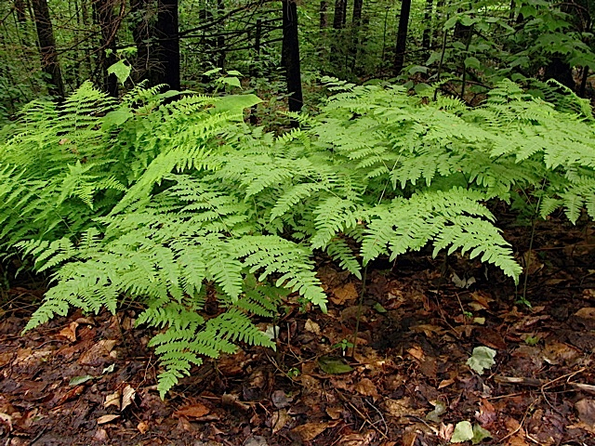
Hemlock (Conium maculatum)  Also known as: poison hemlock, spotted hemlock  ID: A multistemmed perennial weed with toothed, fernlike leaves and clusters of small white flowers. The stems have purple spots, which are most evident near the base of the plant.  Range: Grows wild along roadsides and other open uncultivated areas throughout North America.  The danger: Hemlock leaves, stems and seeds contain several potent neurotoxins that affect both the central and peripheral nervous systems. Four to five pounds is a lethal dose for a horse. Most animals will avoid the plant.  Signs: Signs appear within an hour or two of consumption, starting with nervousness, tremors and incoordination, progressing to depression and diminished heart and respiratory rates and possibly colic. Death results from respiratory failure.  What to do: There is no treatment, but if smaller doses were consumed, animals may recover with supportive care. | 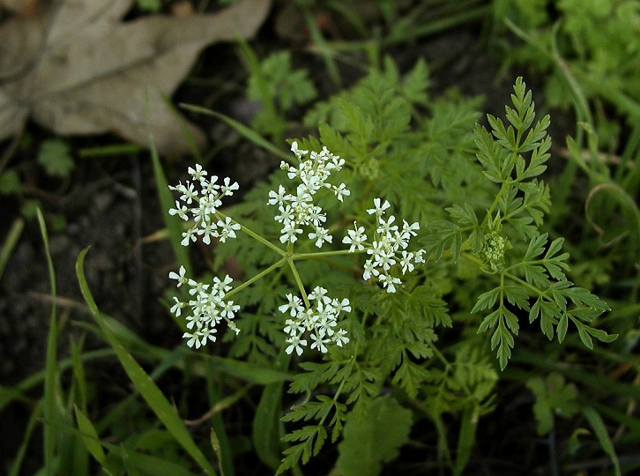
Tansy ragwort (Senecio spp.)  Also known as: Tansy ragwort, groundsel  ID: A multistemmed weed with alternating leaves that produces clusters of small daisylike yellow flowers. Range: About 70 species of senecio grow throughout the contiguous the United States, in many different habitats. Many are common in pastures and along roadsides.  The danger: Levels of toxicity vary among different members of the species, but all are thought to contain at least some concentration of pyrrolizidine alkaloids, which inhibit cell division, especially in the liver. Damage to the liver is cumulative and irreversible, and most horses succumb to chronic exposure over time, after consuming between 50 and 150 pounds, in total. Signs: Often, there is no evidence of consumption until signs of liver failure begin to appear: photosensitization, diminished appetite and weight loss, progressing to depression, incoordination and jaundice.  What to do: There is no treatment for advanced stages of liver disease due to this toxin. | 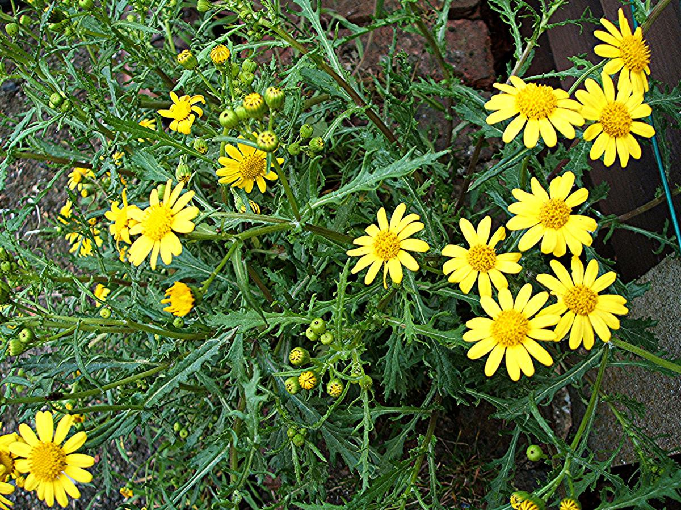
Yellow star thistle (Centauria spp.)  Also known as: Barnaby's thistle  ID: Yellow star thistle is an annual weed that branches out from a single base stem to form a spherical plant up to three feet tall; its round yellow flowers are surrounded by stiff spines 1/2 to 3/4 of an inch long. Russian knapweed spreads via a creeping root system; its erect, stiff stems grow two to three feet high and are covered with gray hairs, and its thistlelike flowers range from purple to white; Russian knapweed has no spines or prickles.  Range: Both plants appear throughout the Western United States, approximately from Missouri to California, and from Mexico northward, almost to Canada. They appear as weeds along roadsides, in cultivated fields and pastures.  The danger: Both plants contain a toxic agent that has a neurological effect on the brain that inhibits the nerves and control chewing. The poisoning is chronic in nature; to receive a toxic dose, horses must consume 50 to 200 percent of their body weight over 30 to 90 days.  Signs: Affected horses may appear to have tense or clenched facial muscles, and they are unable to bite or chew their food effectively. Weight loss is also common.  What to do: There is no treatment, and any neural damage is permanent. Euthanasia is recommended if the horse is too debilitated to eat. | 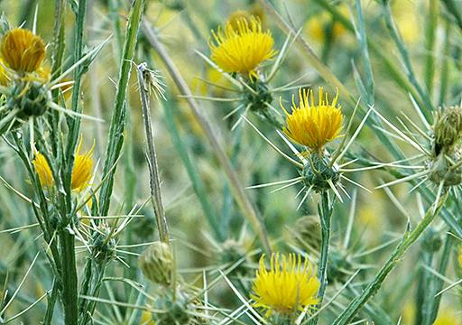
Yew (Taxus spp.)  ID: A woody evergreen shrub with closely spaced, flat, needlelike leaves a half-inch to one inch long. Berries are bright red or yellow, soft and juicy with a hole in the end, where the dark seed is visible.  Range: Western yew and American yew are native to the West Coast and to the Eastern and central United States, respectively, but these two species along with the Japanese and English yews are commonly planted as ornamentals nationwide.  The danger: All parts of the yew plant, except for the fleshy portion of the berries, contain taxine, an alkaloid that causes respiratory and cardiac collapse. The leaves remain toxic even after dried. A single mouthful can be deadly to a horse within minutes.  Signs: Sudden death is the most typical sign of yew ingestion. Animals found alive may be trembling and colicky, with difficulty breathing and a slowed heart rate.  What to do: There is no treatment for yew poisoning. Avoidance is critical; most yew poisonings occur when trimmings are thrown into a pasture after a pruning. | 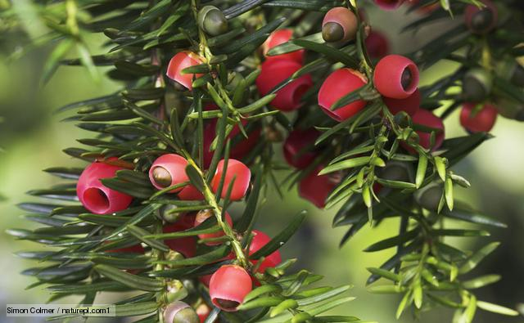
Locoweed (Astragalus spp. or Oxytropis spp.)  Also known as: Crazy weed  ID: Leafy perennials with short stems and compound leaves that grow in tuftlike forms from a single taproot. Some species may be covered with silvery hairs. The flowers, often white or purple, are borne on leafless stalks.  Range: Different species of locoweed--spotted or blue, wooly, purple, Lambert's, two-grooved milk vetch, white-point--grow in varied terrains throughout the West and Southwest, often in dry, sandy soil.  The danger: All toxic species of locoweed contain swainsonine, an alkaloid that inhibits the production of the enzyme necessary for saccharaide metabolism, and the resulting sugar buildup disrupts the function of brain cells.  Signs: Strange behavior is usually the first evidence noticed; horses may bob their heads, adopt exaggerated, high-stepping gaits or stagger and fall.  What to do: There is no treatment for advanced locoism, and its effects are irreversible. Horses with less severe poisoning may recover when access to the weed is removed. | 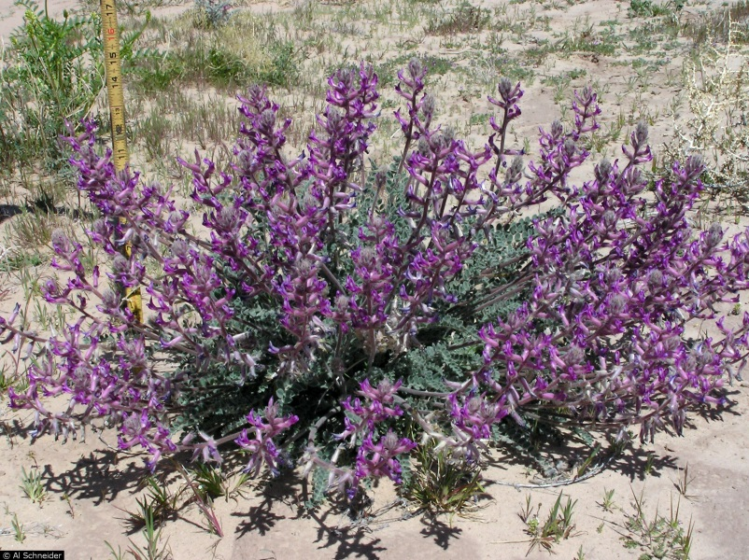
Hoary alyssum Scientific name: Berteroa incana (L.) DC.  Habitat: Often found in poorer producing areas, especially sandy or gravelly soils. It is also found in fields that have been recently disturbed. It can be found in pastures or hayfields.  Description: Hoary alyssum is a herbaceous plant with a grayish green stem and typically 1 to 4 feet tall. Leaves are oblong and covered with hairs. The seedpods are oblong and pointed on the end. Plants produce multiple white flowers ¼ inch wide with four deeply divided petals on each. The plant will bloom and produce seeds throughout the entire growing season, even in the early spring before good established pasture is available.  Exposure: Hoary alyssum is toxic in both fresh (pasture) and dry (hay) form. Toxicity is most common with hay because horses are less likely to consume the weed in a productive pasture. The toxic principle has not been identified.  Clinical signs: Symptoms usually occur between 12 and 48 hours after ingestion. The most common symptoms are swelling of the lower legs (“stocking up”), fever, colic and laminitis. Death is rare but has been observed in horses consuming hay containing greater than 30 percent hoary alyssum. Long-term lameness issues related to founder may result.  Treatment: Remove the source of hoary alyssum from the diet. Treat symptoms with appropriate supportive care. Recovery may take days to months, depending on the severity of the symptoms. | 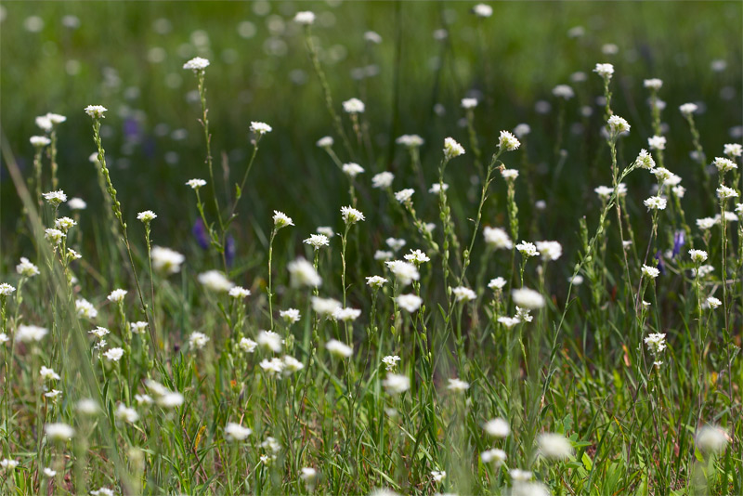
Saint-John’s-Wort  Habitat: Often found in poorer producing areas, especially sandy or gravelly soils, and in overgrazed areas, along roadsides and in open woods.  Description: This perennial herb grows 1 to 1 1/2 feet tall. It has 1/2- to 1-inch-long, flattopped clusters of golden yellow flowers that are 3/4 to 1 inch broad. Bloom occurs from midsummer to late fall. The five petals often have distinct black dots around their edges, and the leaves may have similar dots. The black dots are glands that contain hypericin, the toxic principle.  Exposure: Young, tender (vegetative) plants are the most likely to be grazed; mature plants have low palatability. Horses will consume the mature plants only when feed is extremely limited. Hypericin remains active when dried, so hay with large quantities of vegetative Saint-John’s-wort should be avoided.  Clinical signs: Hypericin causes chemically induced sunburn. Much like alsike clover, hypericin causes photosensitization of nonpigmented areas of the skin. The mucous membranes around the eyes and muzzle may also be affected.  Treatment: Remove Saint-John’s-wort from the animal’s diet. Remove the animal from direct sunlight for a few weeks. Treat sunburn with moisturizers and antibiotics, as recommended by a veterinarian. | 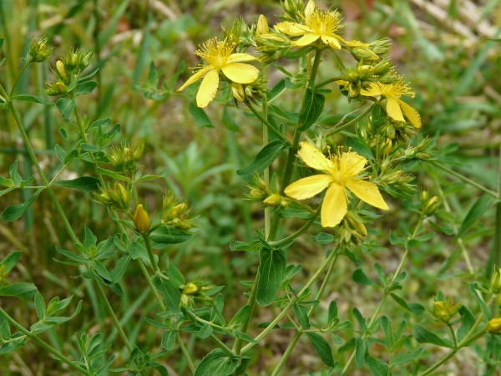
Black nightshade Scientific name: Solanum ptychanthum Dunal  Habitat: Black nightshade commonly grows in open woods, old fields, waste areas, pastures, along roadsides and around farm buildings.  Description: Black nightshade is a low-branching annual 1 to 2 feet tall with triangular stems that bear oval, thin-textured, alternate leaves with wavy margins. 3 Toxic plants of concern in pastures and hay for Michigan horses flowers, borne in drooping clusters on lateral stalks between the leaves, resemble tomato flowers. The berry (fruit) is green when immature and purplish black when ripe.  Exposure: All parts of the plant are potentially toxic, but it is not palatable and is rarely consumed by horses on pasture. The risk of toxicity increases when it is contained in hay. The major toxin is solanine, an alkaloidal glycoside.  Clinical signs: Clinical signs of poisoning by plants in the nightshade family tend to reflect gastrointestinal irritation and/or effects on the central nervous system. Gastrointestinal signs can include poor appetite, abdominal pain and diarrhea, which may become bloody. Central nervous system signs can include depression, difficulty breathing, lack of coordination, weakness, collapse, convulsions and possible death. In some cases, chronic toxicity can develop when animals consume a small amount of nightshade each day for a long period of time. These animals tend to be unthrifty and depressed, and have diarrhea or constipation.  Treatment: Treatment is largely symptomatic until the clinical signs wear off, usually a day or two. Death is rare in animals. | 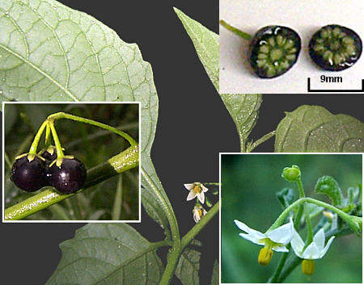
White snakeroot Scientific name: Eupatorium rugosum  Habitat: White snakeroot is found in woods, damp and shady pastures, and occasionally in thickets and clearings, especially at the edges of wooded areas. It grows only in shaded areas.  Description: White snakeroot grows from fibrous, matted roots as a smooth, erect, perennial herb 1 to 3 feet high. It has opposite, oval, pointed-tipped leaves with sharply toothed edges. The upper surfaces of the leaves are dull; the lower surfaces are shiny with three prominent main veins. Small, white flowers in compound terminal clusters are conspicuous in late summer.  Exposure: This plant is highly toxic all year on pasture and remains toxic when dried in hay. Single or multiple ingestions of 1 to 10 percent of a horse’s body weight can be lethal. Snakeroot contains tremetol, a viscous oil extract that contains numerous toxic chemicals.  Clinical signs: Symptoms generally occur within 1 to 2 days after ingestion and include muscle tremors, elevated heart rate, muscle weakness, congestive heart failure, cardiac arrhythmias and difficulty swallowing.  Treatment: Prevention by fencing off wooded areas and providing supplemental forage during dry periods is the best approach. If an animal does ingest white snakeroot, the required treatment is activated charcoal and a cathartic administered as soon as possible by a veterinarian. | 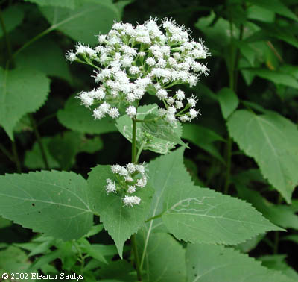
Jimson weed Scientific name: Datura stramonium L.  Habitat: Jimson weed (also called jimpson weed) commonly grows in cultivated fields, waste areas, barnyards, abandoned pastures, roadsides and feedlots.  Description: This stout, coarse annual grows to 5 feet tall with strongly scented, coarsely toothed, green or purplish alternate leaves. The large, trumpet-shaped flowers are white or purplish and are formed singly at forks in the stems. The fruits are hard, spiny capsules that split open along four lines at maturity to release numerous tiny, black seeds.  Exposure: Animals will avoid eating Jimson weed whenever possible. Even when forages are scarce, animals are reluctant to consume this plant. For animals, the danger lies primarily in the consumption of seeds that contaminate prepared feeds such as hay, grains or processed feeds. Jimson weed contains many toxic components — in particular, alkaloids. As much as 0.7 percent of the fresh weight of the leaves may be toxic alkaloids. The seeds are believed to have alkaloid concentrations greater than those in the leaves and stems, and even the nectar is toxic.  Clinical signs: Symptoms can occur within several minutes to several hours and include seeking water to drink, dilated pupils, agitation, increased heart rate, trembling and convulsions (which may be violent). Horses may act as if they don’t know where they are or appear to be seeing things or people that aren’t there. Animals may also become comatose and possibly die.  Treatment: The owner should not attempt treatment — convulsions can be violent and dangerous. Contact a veterinarian quickly — medications are available to counteract the toxic effects of the alkaloids. | 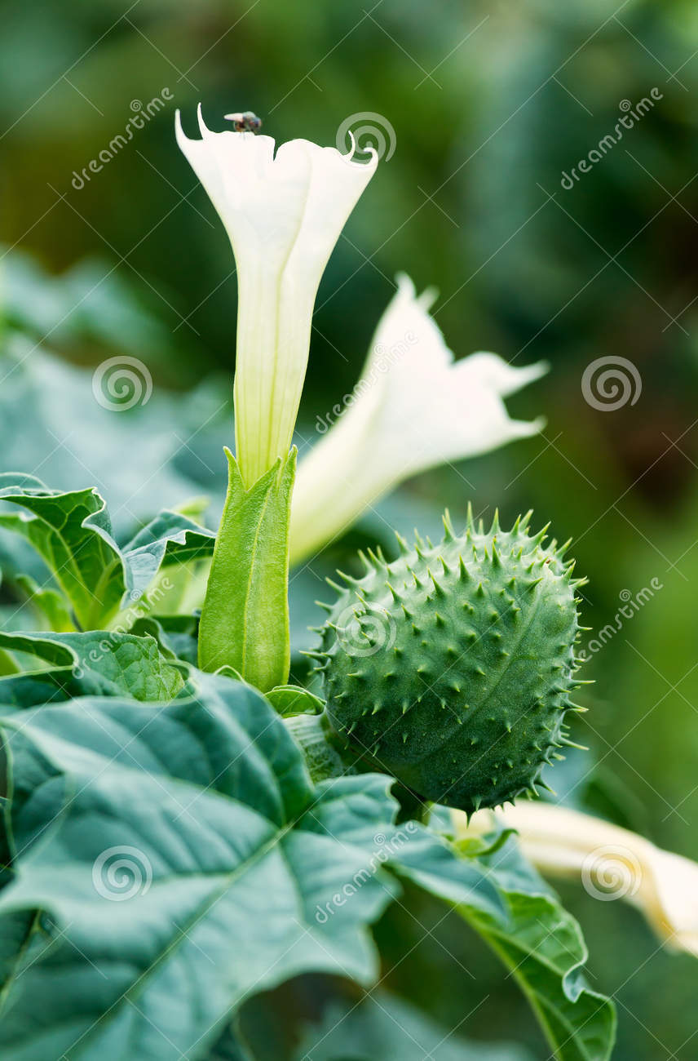
Common milkweed Scientific name: Asclepias syriaca L.  Habitat: Milkweed grows in woods and swamps but most commonly in dry soils of fields and roadsides.  Description: Milkweed get its name from the thick, sticky, milky sap that oozes out of cut or torn leaves, stems and fresh pods. The usually solitary stems of milkweed grow 1 to 5 feet tall and bear opposite (sometimes whorled), sometimes fleshy leaves with smooth margins. Flowers emerge in umbrella-like clusters and range in color from pink to rose-purple to orange or white. The fruit is a pod with cottony seeds.  Exposure: Milkweed plants are considered unpalatable and are eaten only when other forages are not available. They may also be found in hay. The primary toxic principles are cardiac glycosides that cause gastrointestinal, cardiac and respiratory problems and can cause death if enough is consumed. Resins (especially galitoxin) in the milky sap may also contribute to the toxicity of milkweed. The toxic effects are found in both fresh and dried forms; hay containing milkweed should be avoided.  Clinical signs: Symptoms of milkweed ingestion include colic, diarrhea, abnormal heart rate and rhythm; rarely, death. Horses are very reluctant to eat this plant, and its toxicity is only rarely reported.  Treatment: There is no antidote if an animal consumes milkweed. | 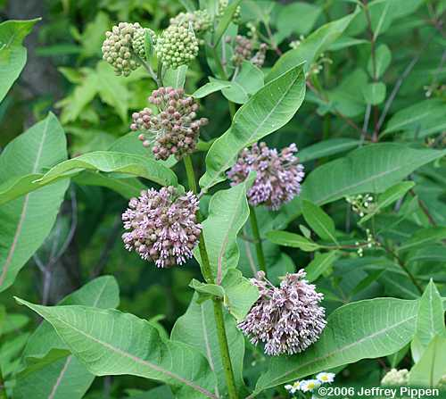
Lawn Grasses  Resist the temptation to toss lawn clippings to your horse, even if you spread them out. First, lawns are not planted with the nutritional needs of horses in mind, nor are they properly maintained for horses. Lawn weed control and fertilization practices could be toxic. Further, any change in your horse’s nutritional balance can upset his digestion and cause colic or laminitis. Finally, clippings from common ornamental plants, flowers and shrubs -- some potentially toxic to horses -- planted in close proximity to lawns could inadvertently mix with lawn clippings.  Choke  When your horse grazes naturally, he tears it with his teeth and chews as he slowly walks. This process prevents him from eating the grass so quickly that it clumps together and lodges in his throat. With cut grass, particularly if it’s clumped in rows or piles, your horse eliminates these natural grazing steps. If he is prone to eating quickly since he doesn't have to pluck it and consumes a lot of cut grass, it can lodge in his throat and cause a condition called choke. You should never try to dislodge something from your horse’s throat -- always call a veterinarian if this occurs.  Mold and Botulism  Hay is grass that has been cut and dried properly before it is baled or rolled. Hay growers carefully time when they cut and bale to ensure the hay stays dry; otherwise, the grass can ferment and mold, and prove fatal for horses. This same process can easily occur in clumped or piled grass clippings. Also, if the grass was mowed improperly -- for example, too short so that soil is mixed with the clippings -- it could expose your horse to the bacteria that cause botulism, particularly if left clumped.  Colic and Laminitis  If your horse is prone to colic, laminitis or both, make it a rule not to allow grass clippings in his diet under any circumstances. Without the grazing process to naturally slow his intake, he will consume more grass and potentially upset the normal fermentation process of his digestive system, leading to any of these potentially fatal conditions. | 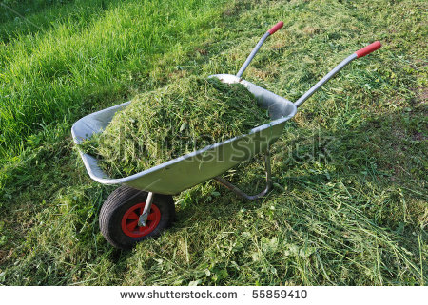
FOXGLOVE (Digitalis purpurea)  Toxicity rating: High Toxins: Digitoxin and cardiac glycosides. The whole plant is toxic. Ingestion of this plant can be fatal at any time during the life of the plant.  Signs: Dizziness, vomiting, irregular heartbeat, delirium, hallucinations, convulsions, sudden death. Because of the unpalatable nature of the plant, poisoning is infrequent, when it does occur it is often severe and dramatic.  Description of plant: A biennial plant, whose basal rosette has soft, hairy, toothed, ovate shaped leaves. Second year growth produces flowering stems 3 – 6 feet tall with spikes that have purple to white spotted, thimble-like flowers that hang down and last about 6 days. First year growth can be mistaken for Comfrey. | 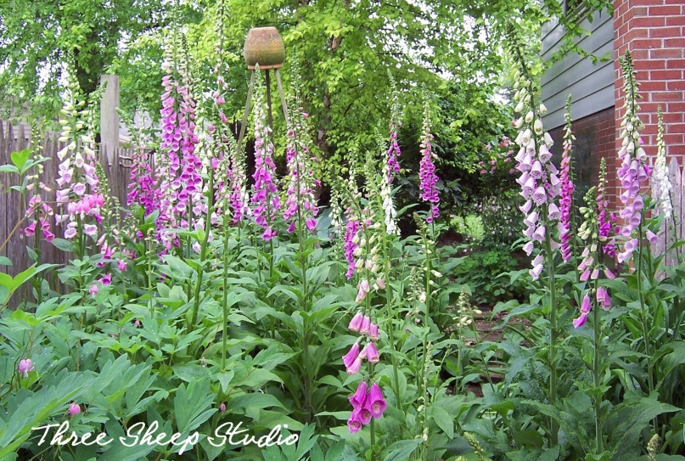
FIELD HORSETAIL (Equisetum spp.)  Toxicity rating: Moderate for most animals, high toxicity in horses Toxins: Thiaminase. All parts of the plant are toxic, both fresh and dried. Hay containing this weed may be more poisonous than fresh plants in the field.  Signs: Weight loss, weakness, gait abnormalities, abnormal heart rate, inability to rise, death. Horses suffer from Vitamin B1 deficiency, causing degeneration of peripheral nerves.  Description of plants: Tenacious perennial plants with stiff, hollow stems that are round and jointed. Field horsetail has green shoots that bear pine needle-like branches that look like a horse’s tail. | 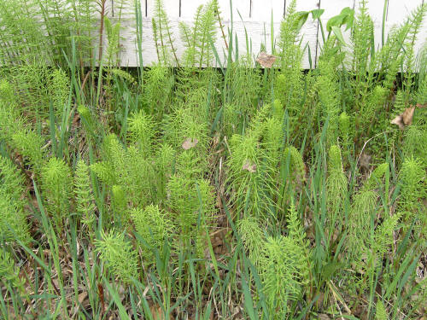
Black Walnut  Plant Description The black walnut tree is a tree that often grows between 70-100 feet tall, though in wooded areas it has been seen as tall as 150 feet.  Geographic Locations The black walnut grows throughout the eastern United States. It is usually found in bottomlands, and other areas with rich, moist soil. It has a green fruit that is a few inches in diameter which can be broken open to reveal a brown nut.  Toxic Plant Components The entire tree is toxic: roots, leaves, bark, nuts.  Toxicity Cause and Symptoms This is one of the few plants that is not toxic when eaten. Instead, it is toxic when your horse's feet come in contact with it. The exact toxic compound in the tree is unknown. The usual method for your horse's hooves to come in contact with black locust is if the shavings in your stalls contain black walnut. Shavings that contain as little as 10% black walnut can cause problems. Because of this it is essential to always know where your shavings are coming from, and if you get them from a saw mill to explain to the personnel why you cannot have any black walnut in your shavings. Another way for your horse to come into contact with black walnut is if these trees border your pasture. When the nuts fall in the autumn, they can easily fall into pastures, since the tree grows so large. The only symptom of black walnut tree poisoning is laminitis. It may come on quickly, or it may slowly develop, depending on how much black walnut your horse has come into contact with.  Cure and Treatment The cure is to treat the laminitis symptoms, and to prevent poisoning to begin with, ensure that your horse has no access to black walnut on the ground. If there are trees bordering your pasture, ensure that you remove your horse from the pasture during autumn and remove the nuts from the ground. | 