**Tetrathlon Information**

Tetrathlon is a competitive Pony Club sport that encourages athletic development of members along with their mounts. There are 4 phases – Running, Riding, Swimming, and Shooting

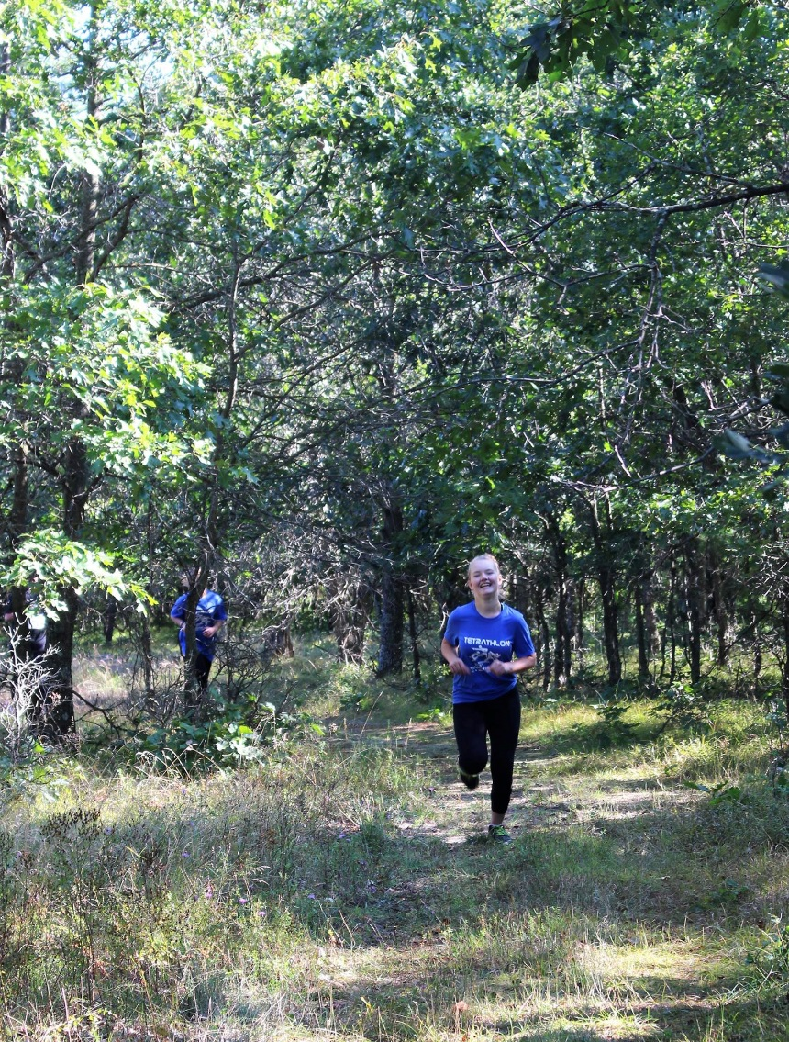

**Running Phase:** Members run a distance course through the woods and pastures that could range from 500m to 3000m depending on member’s age and certification level.

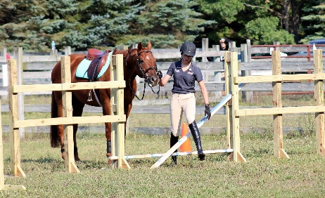

**Riding Phase:** Riding is similar to a timed show jumping course with the addition of two obstacles unique to Tet. The Gate is to be opened and closed under 60 seconds while mounted. The Drop Fence requires the competitor to dismount, lead their horse through the obstacle, and remount. Both obstacles occur in the middle of the jumping course. For this rally, a horse can be shared between participants that are on the same team as long as it is suitable for both riders.

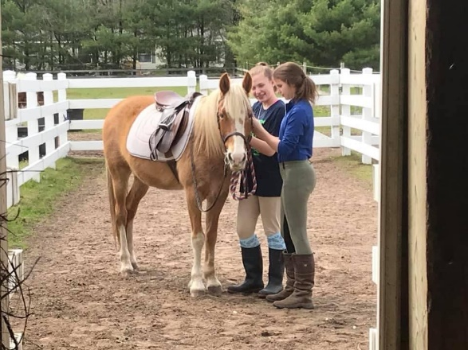

**Horse Management:** Judged as a team just like a normal rally, the main difference being there are no stable managers and horse sharing is encouraged (up to 3 people per horse during a rally).

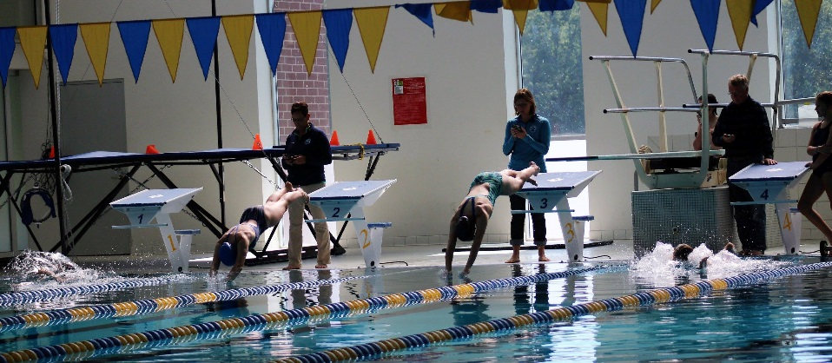**Swimming Phase:** Members swim in a 25 yard pool a distance that ranges from 25yd to 200yd. Any swimming stroke is acceptable, and accommodations can be made for participants that are not strong swimmers.

**Shooting Phase:** Competitors use an air pistol to hit a target that is 10 meters away. This phase emphasizes focus and control. Range safety is very important, so all participants will receive safety instruction as part of this phase, and the range is managed by a hand selected and qualified volunteer. If you do not have your own air pistol, you may borrow one from Pierport Pony Club.

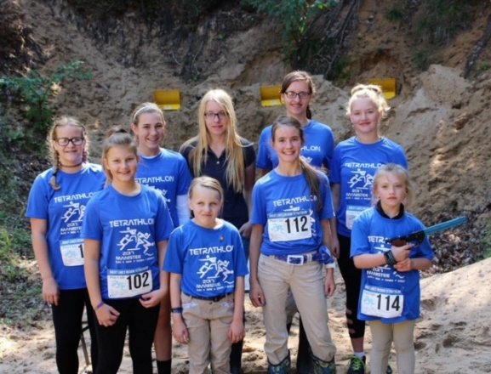

The Great Lakes region will be hosting Flex Rally in June which includes the opportunity to compete in Tetrathlon as part of the rally.

Look for the rally packet this spring.

**Tetrathlon Camp Registration Packet**

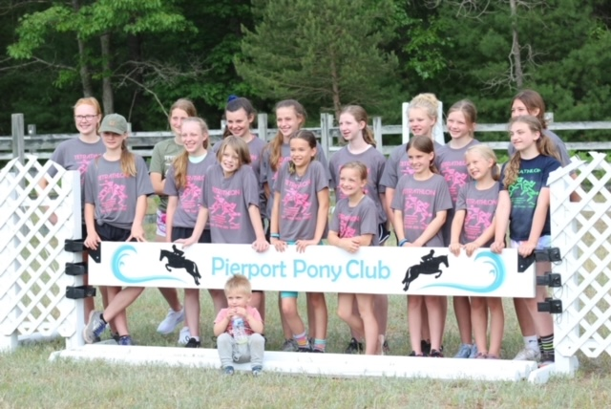The re-introduction of Tetrathlon into the region has been a great opportunity for our members. In fact, it has been such a fun time that members requested an annual camp or clinic earlier in the year to help prepare for the competition in the fall.

And so…Tetrathlon Camp was born.

Participants will receive instruction and coaching on all 4 phases of Tetrathlon. During camp, you will ride, run cross country, swim in the pool, and practice with an air pistol. In addition, members will enjoy a trip to the beach, horse management instruction, Tetrathlon strategizing, training related to health and nutrition to improve their innate athletic ability, and most importantly…bonding with each other.

If you cannot bring your own mount, you may attend unmounted, or you may borrow a suitable Pierport horse for an additional fee. One horse may be shared by 2 participants.

If you do not have your own air pistol, you may borrow one from Pierport for a small fee.

Parents are welcome to audit the sessions.

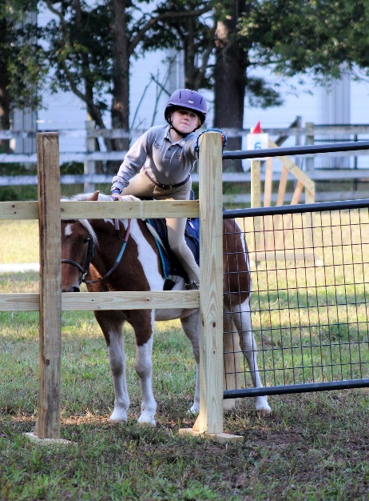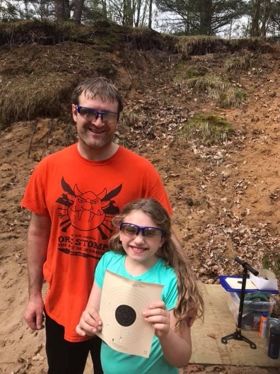**When:** June 3-4

(early check-in/late check-out is available)

**Where:** Fjern Fields – 1539 Critter Trail, Manistee, MI 49660

**Cost:** $135

Cost of camp includes meals for participants, all instruction, and a Tet Camp T-shirt. Lodging is available in nearby hotels, or you may camp on site at no charge.

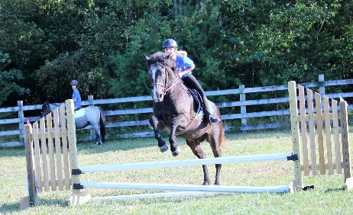

Space may be limited.

Sign-up early to reserve your spot.

**Registration Deadlines:**

Submit payment and paperwork online by **May 8th**.

**Tet Camp Checklist**

**Sleep:**

* Toiletries (shampoo, toothbrush, deodorant, etc…)
* Personal medications/inhalers/epi-pens
* Pajamas
* Tent & Bedding if camping on site

**Swim:**

* One-piece swim suit
* Towel
* Goggles
* Life jacket (if needed)
* Gym bag (separate from your main stuff)

**Run:**

* Running shoes
* Running shorts or pants x2
* Running tights (to wear under your shorts if you want)
* Undergarments (sports bras are recommended)
* Running T-shirt/tank top x2
* Extra clothes x2 (if you want to change after running)
* Warm-ups pants/jacket/sweats (recommended)

**Shoot:**

* Air pistol (if you have your own) w/ lockable case & key
* Ammunition (if you have your own)

0.177 cal soft lead pellets

* Safety glasses (if you have your own)

**General:**

* Medical armband/bracelet
* Water Bottle
* Sunscreen
* Bug Spray
* Helmet
* Riding gloves (if needed)
* Breeches x2
* Riding boots
* Muck boots
* Safety vest (if needed)

**If you are bringing a horse:**

* Copy of Negative Coggin’s & Record Book
* Stall & Feed Cards
* Stall bedding
* Hay & Feed
* Current supplements & equine meds
* Grooming kit
* Water buckets x2
* Fill bucket
* Wash bucket w/body sponge & sweat scraper
* Bridle
* Saddle w/stirrups & leathers
* Saddle Pad x2
* Girth
* Dressage whip, crop, bat (if needed)
* Break-away halter x2
* Lead rope
* Wraps, bandages, or boots you use for jumping & trailering
* Equine thermometer
* Saddle rack & Bridle hooks
* Tack cleaning kit
* Longeing equipment (if needed)

**Where will campers sleep?**

Unlike prior years, we will not have a guaranteed space for campers to stay. Instead please plan to either camp on site or stay in a nearby hotel.

All volunteers are welcome to camp on the property, but hook-ups are not available. There are also several hotels, motels, resorts, and B&B’s in the Manistee area.

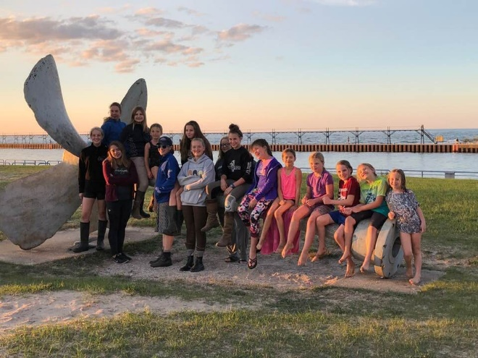**How to register for Tetrathlon Camp:**

1. Determine if you will be bringing a horse.
2. Sign-up using the online forms here:

<http://pierportponyclub.weebly.com/tetrathlon.html>

1. Fill out volunteer forms.
2. Submit payment (either PayPal, Credit Card, or Check)
   1. For PayPal or Credit Card use the site above.
   2. For Check send money to:

Pierport Pony Club

1539 Critter Trail

Manistee, MI 49660

Sharing a horse is encouraged. (2 campers may share the same horse.) If you share a horse, at the very least, I would recommend offering to split the cost of travel, feed, and bedding.

Horses may be housed in either outdoor paddocks or stalls.

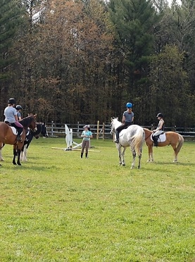

**Can a member attend unmounted?**

You may attend unmounted, but the cost is the same.

Unmounted campers will participate in all sections. However, instead of riding in a lesson, they will be auditing/observing a lesson. This way they can take the skills back home to their own mounts.

**Can I borrow a Pierport Horse?**

If you are not able to arrange to share a horse with a camper, but would still like to participate mounted, Pierport Pony Club may have access to a suitable mount for you. Pierport horses will most likely be kept together in pastures to allow more room for camper horses. To borrow a PPC horse, you must sign up in advance. You may be sharing the horse with another camper. Access to a horse is not guaranteed. If we can secure a suitable Pierport horse for you, the cost will be **$40** and collected at the start of camp.

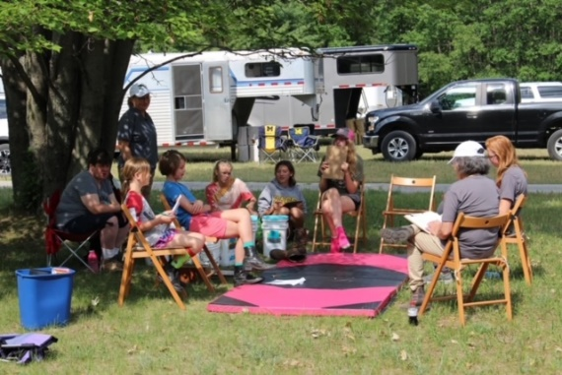

**I don’t have an air pistol…**

Pierport was lucky to win a grant from the Friends of the NRA (political persuasion aside…it was worth about $2600, so we are quite thankful). This grant included 3 very nice air pistols, targets, ammunition, pellet traps, and safety gear. We are happy to share our club pistols with you and you will receive instruction in how to operate them safely. To cover the cost of upkeep and ammunition **$5** will be collected at the start of camp.

**What does the $$ actually pay for?**

* Pierport Pony Club is invested in providing an awesome opportunity for Pony Club members to try out Tet. We hope that Tetrathlon Camp will inspire you to participate in Tet Rally in the future.
* Our goal is to build friendships and personal habits that extend well beyond the realm of Pony Club.
* Tetrathlon provides the unique opportunity to develop athletic ability, riding & horse management skills, endurance, focus, time management, responsibility, and health…all while having a great time with your Pony Club friends.
* We are doing our best to provide this experience at as low a cost as possible. (For example, the facility is being donated to us for the weekend.) Any gains from this camp go directly to supporting the Pierport Pony Club.

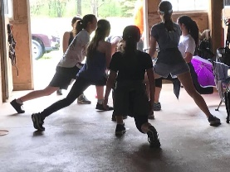**Location:**

Fjern Fields

1539 Critter Trail

Manistee, MI 49660

**Running** will take place in wooded trails and nearby hills.

**Swimming** will take place at the Manistee High School Pool. (A lifeguard will be present.)

**Shooting** will be in the 10m range behind the pastures.

**Riding** will take place ideally outside in a grass pasture, but can move indoors if needed.

**Date/Time:**

* Standard arrival Friday, June 2 from 6-8pm.
* Departure Sunday, June 4 around 5pm.
* Early and late arrivals can be accommodated. Please arrange the time with Ginger so she knows when to expect you. Late Departures can also be arranged to fit your schedule.

A more detailed and personalized schedule will be given to campers upon arrival, but this is what we have done in the past.

**Example Camp Schedule from Previous Years:**



**Volunteering:**

While not required, it would be incredibly helpful if we had a few willing volunteers during camp? Plus its a ton of fun for us adults too! Please read through the volunteer jobs and then check as many as you are able. The form below is so you remember what you signed up for online.

**Friday:**

* HM Assistant
* Jump Course Set Up
* Night Chaperone



**Saturday:**

* Breakfast Prep
* HM Assistant
* Photographer
* Range Assistant
* Lunch Prep
* Pool/Beach Transport
* Jump Crew
* Dinner Prep
* Manure Management
* Night Chaperone

**Sunday:**

* Breakfast Prep
* HM Assistant
* Photographer
* Range Assistant
* Lunch Prep
* Pool Transport
* Jump Crew
* Manure Management
* Jump Course Break Down

Name of Volunteer: ________________________ Relationship to Camper: ___________________________

**Volunteer Job Descriptions:**

HM Assistant (must have barn appropriate footwear)

* Perform a safety check of the horse and rider prior to the camper’s mounted session.
* Check helmet fit, saddle fit, bridle adjustment, jewelry, proper boots, hair pulled back, etc…
* Assist with grooming/tacking-up if needed in the barn.

Hydration Manager:

* Ensure water is always available for participants and volunteers.

Range Assistant:

* Assist the Range Master during shooting.
* Help keep air pistols pumped. Assist campers with loading pellets.
* Help to ensure the range is organized and safe.

Breakfast/Lunch/Dinner Prep:

* Food will be bought/cooked, but help is needed to set it up for campers in an organized way.
* Breakfast: May involve minor cooking of eggs/pancakes
* Lunch: May need to help with making sandwiches/wraps.
* Dinner: May involve the use of a crock-pot.
* Help with set/up & clean/up of lunch and utensils.

Pool/Beach Transport:

* Bring an assigned group of campers to/from the pool using your personal vehicle.
* Bring an assigned group of campers to/from the beach using your personal vehicle.

Jump Crew:

* Assist in setting up course prior to riding.
* Assist riding instructor with jump/pole/grid placement.
* Adjust height of jumps and replace rails as needed.

Manure Management:

* Drive a golf cart with manure spreader attached at key points in the day to help remove stall/paddock waste.

Night Chaperone:

* Sleep on a couch/bed in the viewing room of the barn with the campers (no need for a hotel room).
* Be the adult responsible in case of emergency.
* Ensure everyone goes to bed at lights out.
* Utilize a few older campers to perform a night check in the barn.