Tetrathlon Information

Tetrathlon is a competitive Pony Club sport that encourages athletic development of members along with their mounts. There are 4 phases – Running, Riding, Swimming, and Shooting

Running Phase: Members run a distance course through the woods and pastures that could range from 0.5K to 3K depending on member’s age and certification level.

Riding Phase: Riding is similar to a timed show jumping course with the addition of two obstacles unique to Tet. The Gate is to be opened and closed under 60 seconds while mounted. The Drop Fence requires the competitor to dismount, lead their horse through the obstacle, and remount. Both obstacles occur in the middle of the jumping course. For this rally, a horse can be shared between participants that are on the same team as long as it is suitable for both riders.

Swimming Phase: Members swim in a 25 yard pool a distance that ranges from 25yd to 200yd. Any swimming stroke is acceptable, and accommodations can be made for participants that are not strong swimmers.

Shooting Phase: Competitors use an air pistol to hit a target that is 10 meters away. This phase emphasizes focus and control. Range safety is very important, so all participants will receive safety instruction as part of this phase, and the range is managed by a hand selected and qualified volunteer. If you do not have your own air pistol, you may borrow one from Pierport Pony Club.

This year, Pierport Pony Club will be hosting a qualifying rally to support members interested in attending Festival 2020.

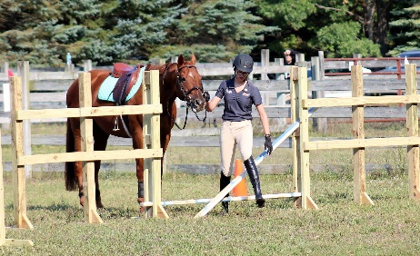
Tetrathlon scoring is very unique and determining your ideal division can be very strategic. If you are unsure about a distance or height related to your division, you have the option to compete at a lower level with a penalty to your score.

When: Tetrathlon Camp is May 17-19.

Tetrathlon Rally is Sept. 7-8 (early check-in/late check-out is available)

Where: Fjern Fields – 1539 Critter Trail, Manistee, MI 49660

The camp packet is below…Look for the rally packet in early July.

Tetrathlon Camp Registration Packet

In 2017 we held Tetrathlon Rally and it was a great success. In fact it was so much fun that members requested a camp or clinic earlier in the year to help prepare for the competition.
And so…Tetrathlon Camp was born. We will continue the tradition for 2019.

Every day participants will receive instruction and coaching on all 4 phases of Tetrathlon. Once per day, you will ride, run cross country, swim in the pool, and practice with an air pistol. In addition, members will enjoy a bonfire, a trip to the beach, horse management instruction, Tetrathlon strategizing, and training related to health and nutrition to improve their innate athletic ability.

If you cannot bring your own mount, you may attend unmounted, or you may borrow a suitable Pierport horse for an additional $30 fee. One horse may be shared by 2 participants.

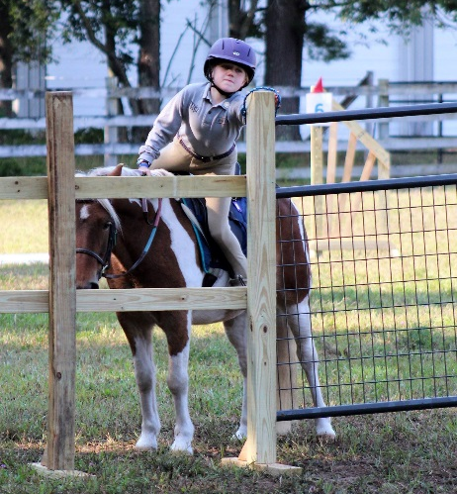
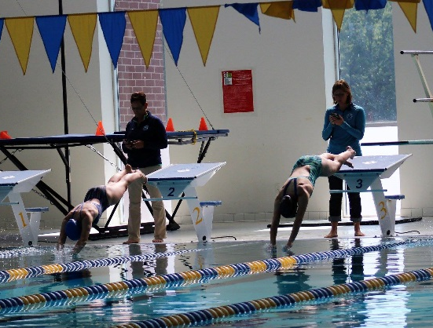
If you do not have your own air pistol, you may borrow one from Pierport for a small $5 fee.
Parents are welcome to audit the sessions.

When: May 17-19 (early check-in/late check-out is available)

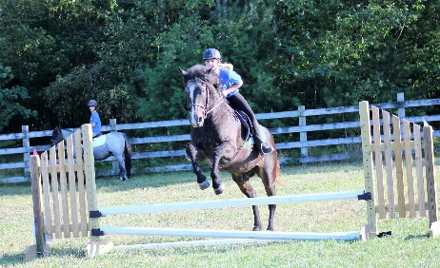
Where: Fjern Fields – 1539 Critter Trail, Manistee, MI 49660

Cost: $125

Cost of camp includes meals/lodging for participants. Lodging is on site in the barn, bring a camping mat, sleeping bag, and pillow.

Space may be limited.
Sign-up early to reserve your spot.

Registration Deadlines:
Turn in your payment and paperwork by May 3rd.

Tet Camp Checklist

Sleep:
- Sleeping bag
- Pillow
- Camping mat/yoga mat
- Toiletries (shampoo, toothbrush, deodorant, etc…)
- Personal medications/inhalers/epi-pens
- Pajamas
- Flash light

Swim:
- One-piece swim suit
- Towel
- Goggles
- Life jacket (if needed)
- Gym bag (separate from your main stuff)

Run:
- Running shoes
- Running shorts or pants x3
- Running tights (to wear under your shorts if you want)
- Undergarments (sports bras are recommended)
- Running T-shirt/tank top x3
- Extra clothes x3 (if you want to change after running)
- Warm-ups pants/jacket/sweats (recommended)

Shoot:
- Air pistol (if you have your own) w/ lockable case & key
- Ammunition (if you have your own) 0.177 cal soft lead pellets
- Safety glasses (if you have your own)

Ride:
- Helmet
- Riding gloves (if needed)
- Breeches x2
- Riding boots
- Muck boots
- Safety vest (if needed)
- Medical armband/bracelet

If you are bringing a horse:
- Stall & Feed Cards
- Stall bedding
- Hay
- Feed
- Current supplements
- Current equine medications
- Grooming kit
- Water buckets x2
- Fill bucket
- Wash bucket w/body sponge & sweat scraper
- Bridle
- Saddle w/stirrups & leathers
- Saddle Pad x2
- Girth
- Dressage whip, crop, bat (if needed)
- Break-away halter x2
- Lead rope
- Wraps, bandages, or boots you use for jumping & trailering
- Equine thermometer
- Saddle rack
- Bridle hooks
- Tack cleaning kit
- Longeing equipment (if needed)

Where will campers sleep?
We will attempt to put everyone in the viewing room in the barn. It is a heated space with a bathroom close by. The arrangement of campers will depend on how many kids there are, ages, etc... If you strongly feel that your child would have a better experience staying off-site with you that is fine as long as they are back by 7am. Male campers are invited, and will stay in Ginger’s House.

All volunteers are welcome to camp on the property, but hook-ups are not available. There are also several hotels, motels, resorts, and B&B’s in the Manistee area.

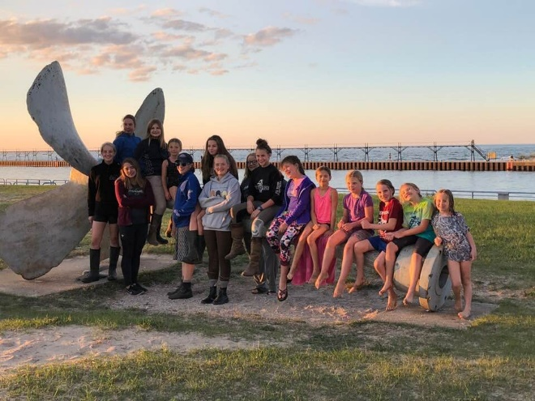
How to register for Tetrathlon Camp:
- Determine if you will be bringing a horse.
- Sign-up using the online forms here:
http://pierportponyclub.weebly.com/tetrathlon.html
- Fill out volunteer forms.
- Submit payment (either PayPal, Credit Card, or Check)
  - For PayPal or Credit Card use the site above.
  - For Check send money to:
Pierport Pony Club
1539 Critter Trail
Manistee, MI 49660

Cost: $125 per camper
Sharing a horse is encouraged. (up to 2 campers may share) If you share a horse, at the very least, I would recommend offering to split the cost of travel, feed, and bedding.
If we have more than 8 horses, some horses may be housed in outdoor paddocks.

Can a member attend unmounted?
You may attend unmounted, but the cost is the same.
Unmounted campers will participate in all sections. However, instead of riding in a lesson, they will be auditing/observing a lesson. This way they can take the skills back home to their own mounts.

Can I borrow a Pierport Horse?
If you are not able to arrange to share a horse with a camper, but would still like to participate mounted, Pierport Pony Club may have access to a suitable mount for you. Pierport horses will most likely be kept together in pastures to allow more room for camper horses. To borrow a PPC horse, you must sign up in advance. You may be sharing the horse with another camper. Access to a horse is not guaranteed. If we can secure a suitable Pierport horse for you, the cost will be $30 and collected at the start of camp.

I don’t have an air pistol…
Pierport was lucky to win a grant from the Friends of the NRA (political persuasion aside…it was worth about $2600, so we are quite thankful). This grant included 3 very nice air pistols, targets, ammunition, pellet traps, and safety gear. We are happy to share our club pistols with you and you will receive instruction in how to operate them safely. To cover the cost of upkeep and ammunition $5 will be collected at the start of camp.

What does the $$ actually pay for?
- Pierport Pony Club is invested in providing an awesome opportunity for Pony Club members to try out Tet. We hope that Tetrathlon Camp will inspire you to participate in Tet Rally this fall.
- Our goal is to build friendships and personal habits that extend well beyond the realm of Pony Club.
- Tetrathlon provides the unique opportunity to develop athletic ability, riding & horse management skills, endurance, focus, time management, responsibility, and health…all while having a great time with your Pony Club friends.
- We are doing our best to provide this experience at as low a cost as possible. (For example, the facility is being donated to us for the weekend.)
- The money paid goes toward the pool fee, meals and snacks, air pistol maintenance, camp shirts, and coaching for each participant in all four phases of Tet. Any gains from this camp go directly to supporting the Pierport Pony Club. If you would like a closer look at our budget, I’m happy to share that with you on an individual basis.
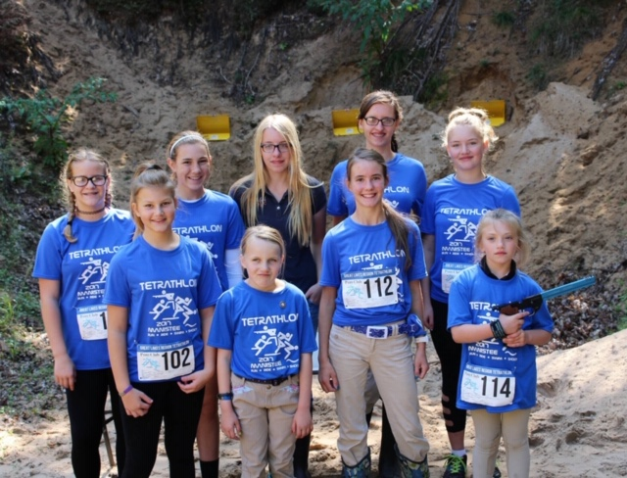
Location:
Fjern Fields
1539 Critter Trail
Manistee, MI 49660

Running will take place in wooded trails and nearby hills.
Swimming will take place at the Manistee High School Pool. (A lifeguard will be present.)
Shooting will be in the 10m range behind the pastures.
Riding will take place ideally outside in a grass pasture, but can move indoors if needed.

Date/Time:
- Standard arrival Friday, May 17 from 6-8pm.
- Departure Sunday, May 19 around 5pm.
- Early and late arrivals can be accommodated. Please arrange the time with Ginger so she knows when to expect you. Late Departures can also be arranged to fit your schedule.

Please review the expected camp schedule. A more detailed and personalized schedule will be given to campers upon arrival.

General Camp Schedule:

Volunteering:
While not required, it would be incredibly helpful if we had a few willing volunteers during camp?
Please read through the volunteer jobs and then check as many as you are able. The form below is so you remember what you signed up for online.

Friday:
- HM Assistant
- Jump Course Set Up
- Night Chaperone

Saturday:
- HM Assistant
- Photographer
- Range Assistant
- Lunch Prep
- Pool/Beach Transport
- Jump Crew
- Dinner Prep
- Bonfire Safety
- Night Chaperone

Sunday:
- HM Assistant
- Photographer
- Range Assistant
- Lunch Prep
- Pool Transport
- Jump Crew
- Jump Course Break Down

Name of Volunteer: ________________________ Relationship to Camper: ___________________________

Volunteer Job Descriptions:
HM Assistant (must have barn appropriate footwear)
- Perform a safety check of the horse and rider prior to the camper’s mounted session.
- Check helmet fit, saddle fit, bridle adjustment, jewelry, proper boots, hair pulled back, etc…
- Assist with grooming/tacking-up if needed in the barn.
Photographer:
- Take group shots and candid shots of members having fun doing Tet stuff.
- Be willing to share those photos with the Tet camp organizer and the rest of the region.
Range Assistant:
- Assist the Range Master during shooting.
- Help keep air pistols pumped. Assist campers with loading pellets.
- Help to ensure the range is organized and safe.
Lunch Prep:
- Food will be bought/cooked, but help is needed to set it up for campers in an organized way.
- May need to help with making sandwiches.
- Help with set/up & clean/up of lunch and utensils.
Pool/Beach Transport:
- Bring an assigned group of campers to/from the pool using your personal vehicle.
- Bring an assigned group of campers to/from the beach using your personal vehicle.
Jump Crew:
- Assist in setting up course prior to riding.
- Assist riding instructor with jump/pole/grid placement.
- Adjust height of jumps and replace rails as needed.
Dinner Prep:
- Slightly more involved than Lunch Prep but a similar idea.
- May involve the use of a crock-pot.
- Help with set/up & clean/up of dinner and utensils.
Bonfire Safety:
- Set up the bonfire and ensure that there is adequate water/sand buckets available to put the fire out.
- Remain until the bonfire is completely put out and all coals are dark and cool.
Night Chaperone:
- Sleep on a couch in the viewing room of the barn with the campers.
- Be the adult responsible in case of emergency.
- Ensure everyone goes to bed at lights out.
- Utilize a few older campers to perform a night check in the barn.

