Topic | Stable Management
D1 | Give 2 reasons for cleaning tack.
D2 | Demonstrate tying a quick release knot (with assistance if necessary). Name 5 grooming tools and describe how to use them. List 3 examples of unsafe horse equipment. Name 3 common stable vices and give 1 possible cause for each vice named.
D3 | Demonstrate and discuss the steps involved in cleaning a stall and discuss the reasons for cleaning a stall. Explain the purpose of banking a stall. Demonstrate and discuss the proper methods of hanging a water bucket and hay net/bag. Discuss how to fit a halter.
C1 | Discuss 1 drainage and 1 absorbent bedding. Correctly put on and adjust a blanket/sheet on a mount. Describe and give reasons for 3 types of clipping. Name 2 internal and 2 external parasites. Discuss general barn safety procedures.
C2 | Discuss 3 concerns for pasture safety and fencing. Discuss emergency information that should be posed in all barns. Name 3 toxic plants in your area and describe appearance. Describe 4 ways to control internal/external parasites in pastures and stalls.
HB | Discuss facility safety including inspections of facility, inspections of mount. Explain at least 5 safety practices all facilities should utilize. Discuss measures to prevent or decrease the spread of diseases. Identify various toxic plants. Discuss their symptoms and care of mount.
HA | Present and discuss a detailed outline of your stable plan. It should include the type of facility, a drawing of the facility, floor plan w/dimensions, construction materials, schedules, manure management, pasture management, seasonal differences, parasite management, poisonous plants, and an emergency plan.

Name: __________________________
- Why is it important to keep you tack clean?

- What does moldy tack look/feel like?

- What does cracked leather look/feel like?

- What does it mean when the stitching is missing?

- Why is it important to clean the stress points on a bridle?

- Explain how to fit a halter:
The noseband of a halter should be __________ fingers below the cheek bone. The noseband should be tight enough that _________________________________________________________________________________ but loose enough that ________________________________________________________________________. The throat latch of the halter is too loose if you can _________________________________________________.
- How high should a water bucket be hung in a stall?

- How high should a hay net be hung in a stall?

- What does it mean when a horse is cast in its stall, and how can you prevent it from happening?

- Can you name each of these types of clips?
Trace, Irish, Bib, Blanket, Full Body, Hunter, Strip, Artistic

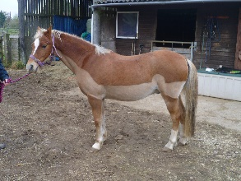 | 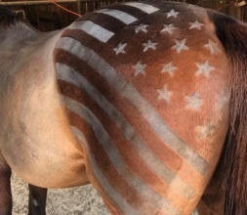 | 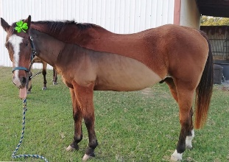 | 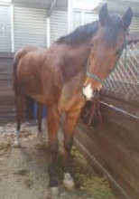
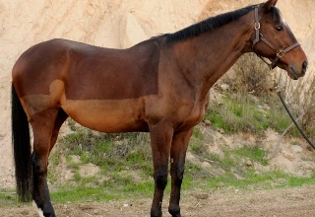 | 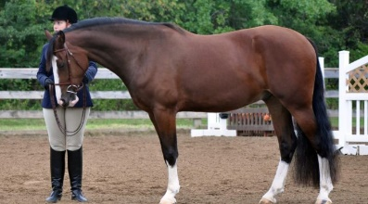 | 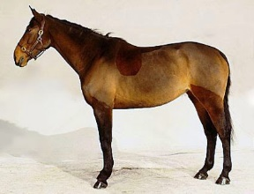 | 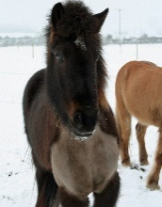

- Put an X over anything your horse should not eat because it is toxic can make them sick.
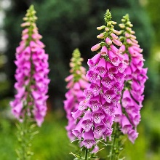 | 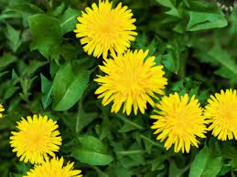 | 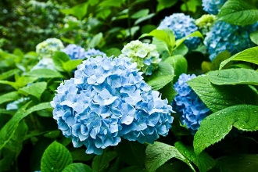 | 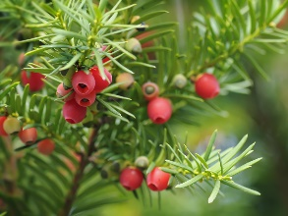 | 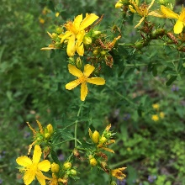
Foxglove | Dandelion | Hydrangea | Yew | St. John’s Wort
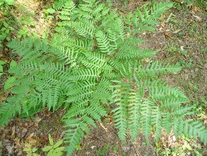 | 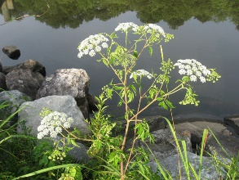 | 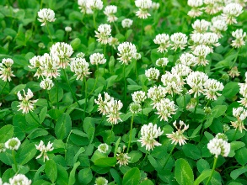 | 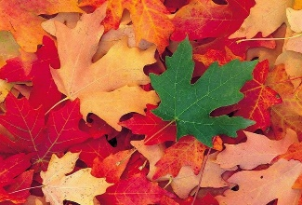 | 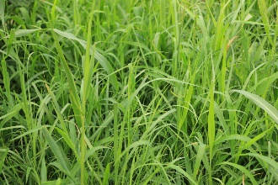
Bracken Fern | Water Hemlock | Clover | Red Maple Leaves | Pasture Grass
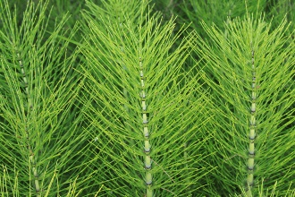 | 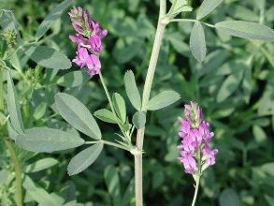 | 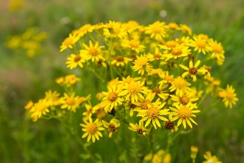 | 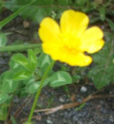 | 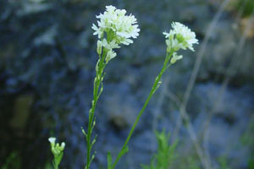
Horsetail | Alfalfa | Tansy Ragwort | Buttercup | Hoary Alyssum

- Cut out each box below and connect each grooming tool with its name, how it is used, and why it is used.

Name | Picture | How | Why
Body brush (soft/short bristles) | 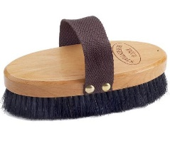 | Use after removing the majority of the dirt and debris from the coat. Brush is the direction of the hair with a longer flicking motion on the body and legs. | This tool helps to produce a shine on the horse’s coat because it brings the oils created by grooming from the skin to the hair and helps remove the final layer of dust.
Body sponge | 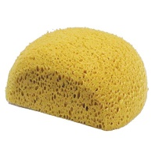 | Saturate with cool water from a bucket and squeeze all over the horse’s body and legs. Can also be used with liniment. | Horses can overheat when they exercise hard during competition or training. Cooling your horse down quickly can be a truly life saving skill.
Dandy brush (stiff/long bristles) | 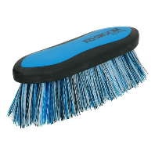 | After currying, use short flicks of your wrist while holding this tool. Always brush in the direction of hair growth. Can be used on the body and legs. | This tool is very effective at removing dirt, hair, and other debris that is on the surface of the horse’s coat.
Face brush (small brush with very soft bristles) |  | This small soft brush is used on the face to gently remove dirt, dust, and other debris. Brush lightly in the direct of the hair avoiding eyes. | This tool is used when other tools might be to harsh for sensitive areas. Primarily it is used on the face because of its small size and soft bristles.
Hoof pick | 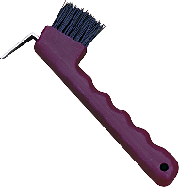 | Use the metal piece to clean next to the frog by digging dirt out and away from you. Use the brush to remove loose debris. | Daily hoof cleaning helps prevent infections, diseases, and injuries to the hoof. It is also important to monitor hoof growth and trimming needs.
Mane & tail brush | 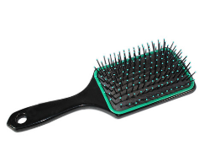 | Remove tangles from the mane and tail by taking smaller pieces and working your way from the bottom of the hair up. The use of detangler can reduce hair breakage. | This tool is used to remove knots, snarls, and tangles from the mane and tail. Combs can also be used, just be aware that brushing a tail tends to make it thinner over time.
Metal curry comb | 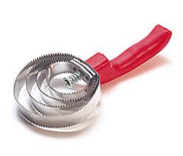 | Use this tool to clean the dandy brush as you groom your horse. This can be used as a shedding tool on a horse that is not very sensitive, but use caution. | Cleaning your brushes as you go helps to remove dirt and debris instead of just spreading it around.
Rub rag | 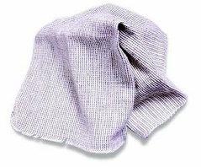 | Get the cloth damp with warm water and rub a stained area vigorously. Follow up with a dandy brush and body brush to smooth the coat back down. | Use to remove grass and manure stains before riding and sweat stains after riding. Can also be used to apply fly spray or coat conditioner to a sensitive horse.
Rubber curry comb | 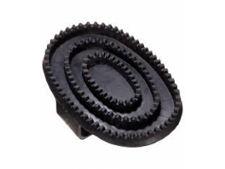 | Use a circular motion while pressing along the horse’s neck, and body. | Currying a horse brings dirt, dust, loose hair, and other debris to the surface of the horse’s coat so it can be removed easily.
Sweat scraper | 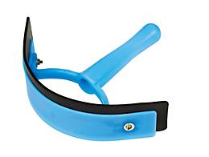 | Start at the neck and use long strokes while pressing into the coat to squeegee water away from the horse’s body. | Remove water after hosing your horse down during cool-out or bathing. This will help the coat dry faster.

