Topic | Rider Safety
D1 | Name 3 pieces of clothing or equipment that you should wear for your safety when you ride.
D2 | Name 3 items that should be included in a human first aid kit. Name 3 pieces of information that are required on the medical armband/bracelet. Describe what you should do for yourself when you fall off a horse.
D3 | Name 2 items that are required to ride in a Pony Club mounted lesson. Give 2 examples of when a riding helmet needs replacing. List some common injuries that may happen when a rider falls off a horse.
C1 | List 3 ways to determine if a riding helmet fits properly. List 3 circumstances where a helmet is required to participate in USPC activities. Describe 3 signs of heat illness.
C2 | List 5 signs of a concussion. Explain 2 ways to cool off a rider during a hot day. Explain the importance of the heat index.
HB | Discuss heat related illnesses. Discuss the signs of a concussion. Discuss what to do in the event a rider falls and what Return to Play means.
HA | Discuss heat stroke, symptoms, and care. Discuss concussion, symptoms, and care. Discuss rider fall care under different circumstances. Discuss the Return to Play protocol.

Pre-Lesson Worksheet: Name: __________________________
- Cross out what you should NOT wear while riding when it comes to rider safety.
Breeches | Polo Shirt | Hoodie | Medical Bracelet | Fashion Bracelet
Bulky Winter Coat | Air-Vest | Cross Country Vest | T-Shirt | Thick Muck Boots
Earmuffs | Riding Gloves | Thick Mittens | Necklace | Stud Earings
Half Chaps | Full Chaps | Sweat Pants | Khaki Pants | Belt
Jeans | Leggings | Riding Helmet | Hoop Earings | Watch
Jodphurs | Tennis Shoes | Bike Helmet | Scrunchies | Medical Armband
Sandals | Shorts | Baseball Cap | Metal Barrettes | Scarf

- When does a helmet need to be replaced?

- What should you do if you someone falls off at Pony Club? What if that someone is you?

- Name some injuries that you have heard could happen if you fall off a horse.

- What is a concussion? What are some common symptoms?

- What is Return to Play? Why is it important?

- How do you know if it is too hot to ride?

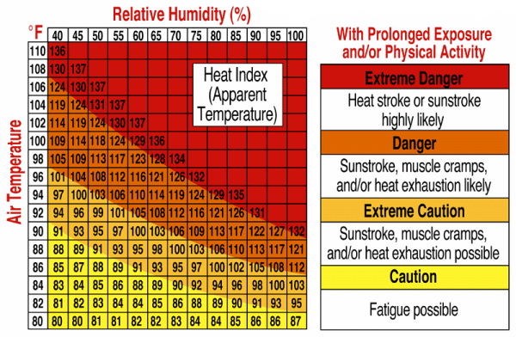
- What information about the weather do you need to properly use the Heat Index?

- What are the three types of heat injuries? Which heat injury is an emergency?

- What are the symptoms of heat cramps?

- What are the symptoms of heat exhaustion?

- What are the symptoms of heat stroke?

- How many required items in the Human First Aid Kit can you list?

