Quiz Study Guide
- General
  - Use the D/C level Flash Cards to quiz each other
  - Practice reciting the USPC pledge HM
  - Part Pictionary: Draw saddle parts, bridle parts, or horse parts, and the others must guess what the part. For an extra challenge, try to identify parts of a Western saddle and bridle. p. 246, 259-262, 264
  - List the items that should be on a stall card HM
  - List the items that should be on a feed card HM
  - Review different attire requirement: Find a tack catalogue (like Dover or Stateline or you can use the internet) to create 3 different posters. One has formal attire, one has informal attire, and one has clinic or casual attire. p. 303-306 or HM
  - Breed Brainstorm – Take turns naming a breed of horse and identify if it is a warmblood, coldblood (draft), hotblood (arabian/thoroughbred), pony, or regular horse. Once everyone passes twice the game ends. Read about the specific breeds in the D manual. p. 252-255
- Stable Management
  - Poisonous Plant Research – Each person on the team should pick 3 different poisonous plants to research. You should know what the plant looks like and how it might affect the horse if it is ingested.
  - Describe how to clean and bank a stall and why that might be important.
  - List at least 2 reasons you should rotate grazing pastures.
  - Explain the difference between rotational deworming practices and deworming based on fecal egg counts. Why do veterinarian associations recommend using fecal egg counts?
- Safety
  - Perform an imaginary safety check p. 273-278
  - Explain proper helmet fit (including adjustment of the chin strap, and where the helmet sits on the head) HM
  - List signs of a concussion HM
  - Explain why hydration is important for a rider and their horse.
  - Act out a heat related scenario and describe the symptoms (heat cramps, heat exhaustion, heat stroke) and the others must determine which type of heat related injury/illness it is, and then act out how to treat them. HM
  - Each person describe an unsafe situation you might find in a barn, stall, feed room, or tack room.
  - Describe how to safely ride in a group inside & outside the arena p. 137-138
  - List all the different ways you can safely pass another horse while riding in the arena p. 127-128
- Tack
  - Review the steps for cleaning tack (what is the actual purpose of saddle soap) p. 268-273
  - Review the types of girths, nosebands, and martingales/breastplates p. 281-282, 288-292
  - Review how to properly fit a bridle (specifically throat latch, nose band & placement, bit size & placement, and browband) p. 284-288
  - Review how to properly fit a saddle (to the rider, to the horse, how many holes should be above/below the billets when the girth is tight, what about saddle rocking, bridging, pinching, and saddle sores) p. 278-283, 295
  - Play a game where you say the name of a bit and the others must draw it and state the type (snaffle, leverage, gag) of bit it is and what discipline it is typically used or not used for (dressage, driving, in hand, western, etc...)
  - Play a game where you race to put together a bridle. Who can do it the fastest? Are all the keepers in place? Can you hang the bridle in a organized way using the figure 8 technique (See the HA manual)? Can you put a bridle together with an unusual noseband (figure 8, flash, crank, kinneton)?
  - Place small tack and equipment in a mystery sock. Each person has to try and guess what is in there just by feel.
- Horse Sports & Competition in USPC
  - Practice drawing a dressage arena, a polocrosse field, and a games arena (include the letters, line names, and dimensions) Arena Supplement
  - List all the specific items in the various rally kits (grooming equipment, individual equipment, feeding equipment, human first-aid, tack room equipment, tack cleaning kit, utility kit, equine first aid kit, extra equipment, cleaning equipment). To make this activity more interactive, gather up an entire club rally kit, dump everything in one giant heap, and work as a team to put everything in their respective categories. HM
  - List all the competitive and non-competitive USPC activities
  - For each competitive activity: State how many mounted/unmounted members are allowed on a team. Explain how the competition is scored. Describe how/why you might be eliminated from the competition.
  - Draw different types of jumps (oxer, ascending oxer, triple bar, cross rail, ground pole, coop, roll top, Liverpool, wall, square oxer, Swedish oxer, plank, gate, ditch, trakehner, brush, skinny, corner, bounce, cavaletti, combination, shark tooth, key hole, vertical, parallel oxer, table, log, bank) C-level Manual
  - Match each color with the correct pony club certification level. HM
- Veterinary Knowledge
  - List the signs for colic, laminitis, heaves or COPD, insulin resistance
  - How do you know if your horse is healthy (what are the typical vital signs, what is an ideal BCS) p. 223
  - Name the main areas of the horse you should evaluate when determining a Body Condition Score (BCS)
  - What are indications that your horse is sick or injured? p. 224-225
  - Describe how to measure TPR and what the typical healthy ranges are p. 224
  - Each person list at least 2 diseases a horse can be vaccinated against p. 229-230
  - Why is a negative Coggin’s test required to participate in USPC activities?
- Conformation
  - List faults of head, neck, should, back, and legs p. 255-257
  - Conformation Charades – Try to act out the different conformation faults and get your team to guess.
- Grooming and Shoeing
  - What items would a farrier or blacksmith use and why C-level Manual
  - Practice drawing different types of shoes C-level Manual
  - Name the parts of the hoof p. 216
  - Describe what is looks/sounds like when a shoe is loose p. 221
  - In proper USPC order describe each grooming tool and how you would use it p. 184-187
- Feeding and Nutrition
  - Take turns reading the basic rules for feeding p. 207
  - Each person take turns listing a type of feed and say if it is roughage, concentrate, or supplement/mineral. The game ends when everyone has passed twice. p. 203-206
- Conditioning
  - Review the training pyramid
  - Explain the benefits of lunging
  - Can you identify various lunging equipment?
  - List the items you should be wearing when lunging your horse.
- Boots & Bandaging
  - Know the difference between polo wraps, quilts, and track bandages, adhesive bandages (like vet-wrap).
  - What is the purpose of each type of bandage (polos, stable bandage, shipping bandage)? What areas on the horse is each bandage meant to protect? p. 231-234
  - Describe when you would use different types of boots and what they should protect (splint boots, open front boots, ankle boots, sports medicine boots, bell boots, shipping boots) p. 233-234, 267-268

Arena Types & Dimensions
Dressage Arena (Large - 20mx60m) (Small – 20mx40, and remove RSVPLI)
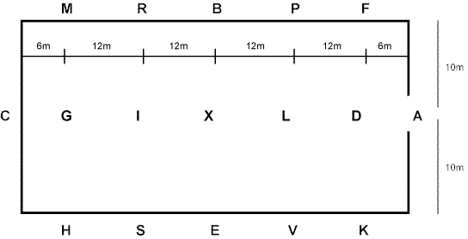

Polocrosse Field
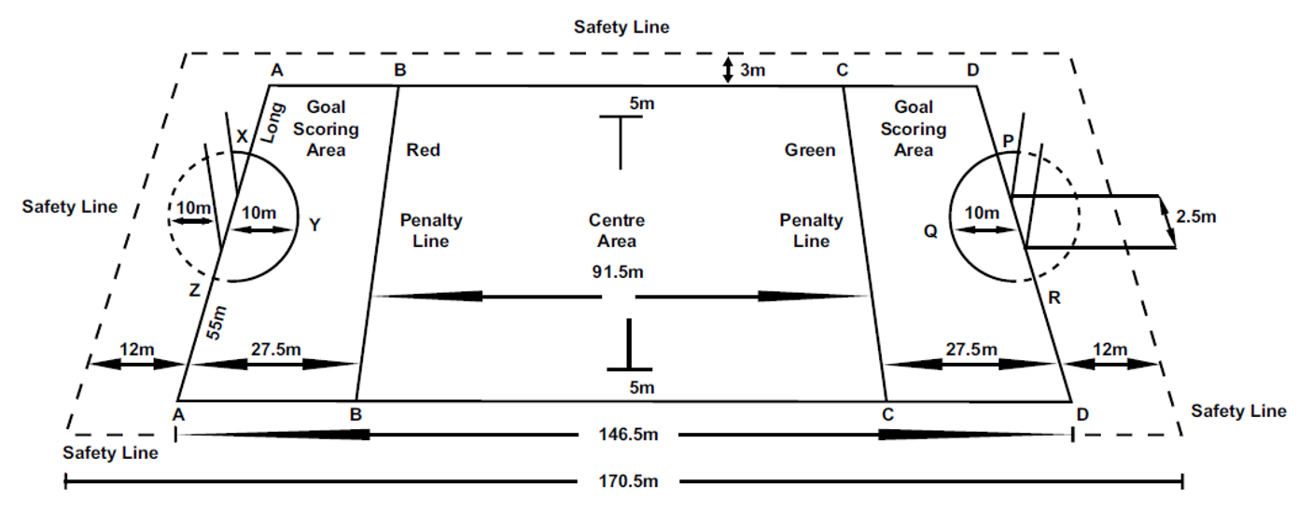
Games Arena
Horse Parts
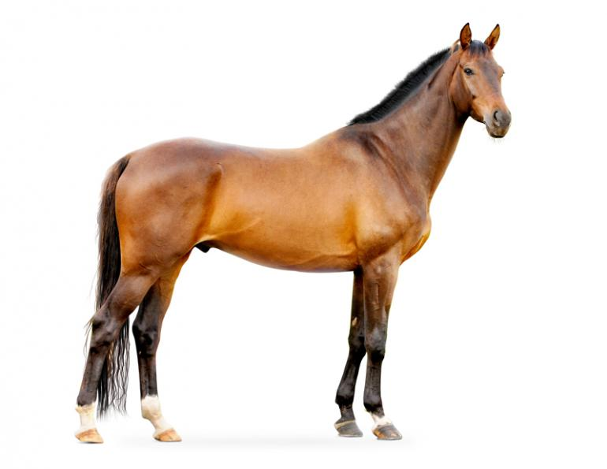

Back
Barrel
Cannon Bone
Cheek
Chin
Coronet Band
Crest
Croup
Ear
Elbow
Eye
Fetlock
Fetlock Joint
Flank
Forearm
Forehead
Forelock
Gaskin
Heel Bulb
Hock
Hoof
Knee
Lips
Loin
Mane
Neck
Nose
Nostril
Pastern
Point of Buttock
Point of Hip
Point of Shoulder
Poll
Stifle
Tail
Tailhead
Toe
Withers

Saddle and Bridle Parts
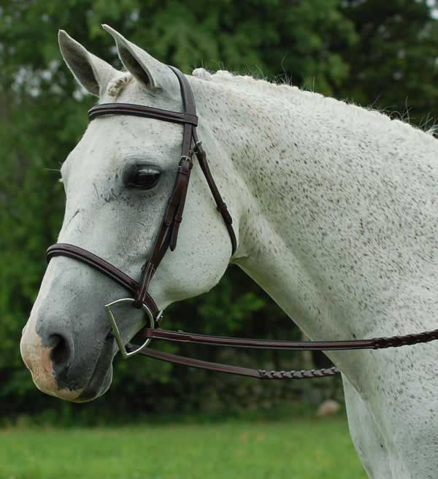
English Bridle
Bit
Browband
Buckle
Cheek Piece
Crown Piece
Keeper
Noseband or Cavesson
Reins
Throat Latch

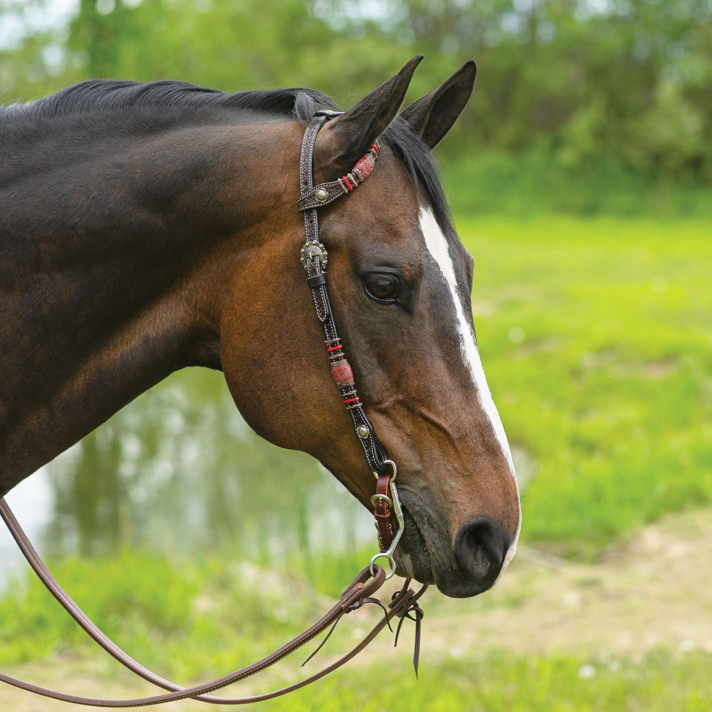
Western Headstall
Bit
Cheek Piece
Crown Piece
Curb Chain or Curb Strap
Ear Piece
Reins

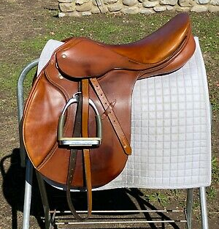
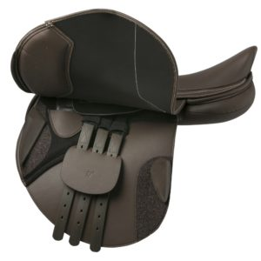
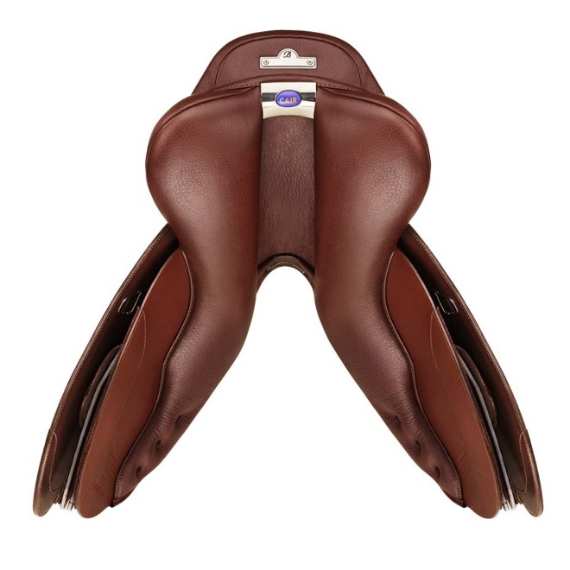
English Saddle
Billet
Billet Guard
Cantle
Channel
D Ring
Flap
Girth
Gullet
Knee Block
Knee Roll
Panel
Point of Tree
Pommel
Saddle Pad
Seat
Skirt
Stirrup Bar
Stirrup Iron
Stirrup Leather
Stirrup Leather Keeper
Stirrup Pad
Sweat Flap
Thigh Block
Twist

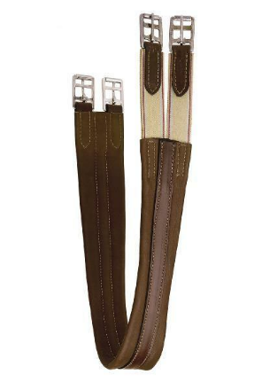
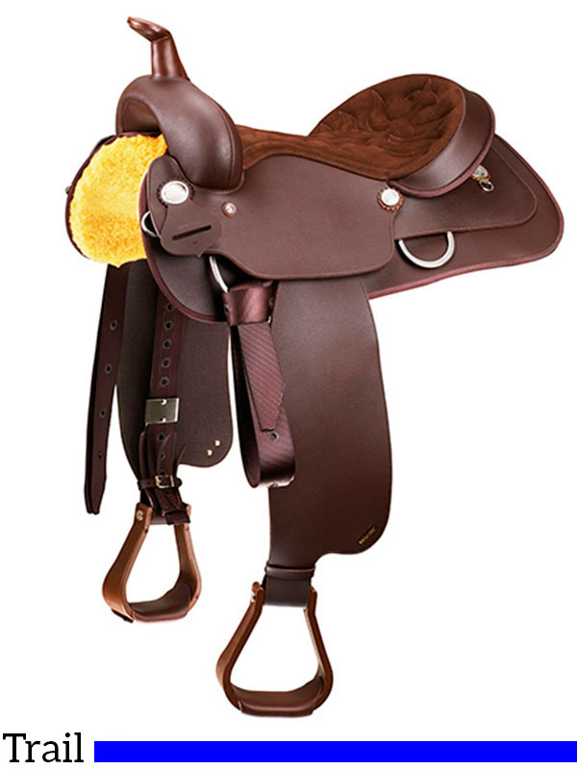

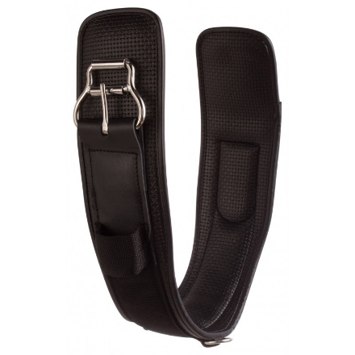

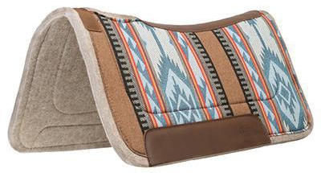

Western Saddle

Back Housing
Blevin’s Buckle
Cantle
Cheyenne Roll
Cinch
Concho
Fender
Fleece
Fork
Horn
Jockey
Latigo
Latigo Holder
Off-side Billet
Rigging
Saddle Pad
Skirt
Stirrup
Stirrup Hobbles
Stirrup Leather
Stirrup Wrap
Swell

