Topic | Nutrition
D1 | Demonstrate how to feed a treat to a pony, Give 1 example of a succulent, Discuss why and how often water should be available
D2 | Give 3 basic rules for feeding and explain feeding schedule for mount.
D3 | Give 5-7 basic rules for feeding. Describe how feeds are measured and weighed. Discuss the amount of roughage and the amount of concentrates per ration for own mount.
C1 | Discuss how much water an average horse drinks in a day and 2 reasons why water is important for horses. Describe 2 characteristics of bad hay. Explain why access to good quality roughage is essential. Discuss amount and type of feed for own mount.
C2 | Describe own mount’s ration when developing fitness, maintaining fitness, taking day off, sick, and roughed out. List the 6 classes of nutrients. Look at a feed label and identify the percentage of protein and fat. From the ingredients list, identify 1 source of carbohydrate, 1 vitamin, and 1 mineral.
HB | Evaluate a sample of hay, grain, and bedding. Discuss the quality of the sample, the availability, cost, origin, and seasonal variation. Discuss a variety of supplements and why they might be used. Review a feed label and identify sources of protein, carbohydrates, and fat from the listed ingredients. Discuss the 6 classes of nutrients, their primary sources, and why they are needed. Discuss various feeding principles and their effect of the digestive system and overall health.
HA | Discuss the characteristics, advantages, and disadvantages of feeds. Discuss the cost and storage of feed. Interpret a fee label for nutritional and portion information. Discuss feed supplements. Discuss complete nutritional programs for various horses. Discuss how certain health conditions require nutritional management.

Pre-Lesson Worksheet: Name: __________________________

- What is the safest way to give a horse a treat?

- If you give a treat with your hand, describe how you would hold the treat to prevent from being bitten. Can you draw it?
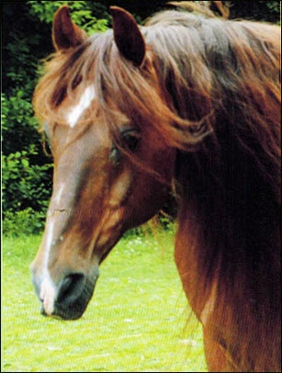
- Why does the water trough or water buckets always need to be full of clean fresh water? How much water does a typical horse drink during the day?

- Given an example of what your horse can eat or drink for each of the following

  - Roughage
  - Concentrate
  - Succulent
  - Salt
  - Water

- What are some signs of hay that is not good for your horse to eat?

- How should you determine the amount of roughage that your horse eats each day?

- How should you determine the amount of grain or concentrate that your horse eats each day?

- How should you adjust your horse’s ration based on…

- His workload?
- His body condition?
- The weather?

- What is the purpose and a primary source of each of the 6 classes of nutrients below?

- Carbohydrate

- Protein

- Fat

- Water

- Mineral

- Vitamin

