Topic | Leading/Longeing
D1 | Approach mount safely and put on halter. Demonstrate walk-halt-walk transitions. Turn in the correct direction.
D2 | Lead mount correctly in tack. Demonstrate walk-trot-halt transitions. Turn in the correct direction.
D3 | Lead safely from both sides at the walk. Demonstrate correctly jogging a mount in a bridle and turning in the correct direction. (Whip must be carried and used appropriately as needed.)
C1 | Discuss 3 reasons for longeing. Discuss necessary longeing equipment. Describe parallel longeing and explain why it might be used. Demonstrate parallel leading.
C2 | Discuss equipment and safety precautions for longeing. Discuss the type and length of the longe line used. In an enclosed area, longe own mount and walk and trot in both directions on a 20m circle (with assistance). While longeing, demonstrate the correct use of equipment, body position, posture, and voice.
HB | Show a mount in hand as if jogging for soundness on a straight line at walk/trot. Show confidence and control with proper leading and correct turns. Identify longeing equipment, discuss their use, proper fit, and the dangers of ill-fitting tack.
HA | Show the horse in hand on a triangle. Demonstrate confidence, control, and correct technique. Discuss the breed, disposition, suitability for a discipline or activity and for performance level, general condition, and conformation & movement. Discuss longeing techniques, proper fit of equipment including side reins, safety when longeing horse, and safety when longeing rider. Demonstration of longeing including proper fit and use of equipment, warm-up, safe, confident, and effective techniques, sufficient knowledge and skills in order to recognize problems and alter plan and training techniques as needed, free forward movement, regular rhythm, acceptance of aids, development of lateral and longitudinal suppleness. Discuss horse’s level of training. Discuss a plan to improve the horse and provide additional suggestions in order to continue the mount’s future training through longeing.

Pre-Lesson Worksheet: Name: __________________________
- In general, what side of the horse should you lead from?

- What is the purpose of a break-away halter?

- How can you tell if your horse is wearing one?

- What is meant by the byte of the lead rope or reins?

- What type of whip should you carry during horse inspections (jog-outs)?

- List the 4 items a member should be wearing when longeing a horse.
1. | 3.
2. | 4.

- Why should you wear a watch while longeing?

- What are some reasons that a horse would be longed?

- Can you identify the equipment used in longeing?
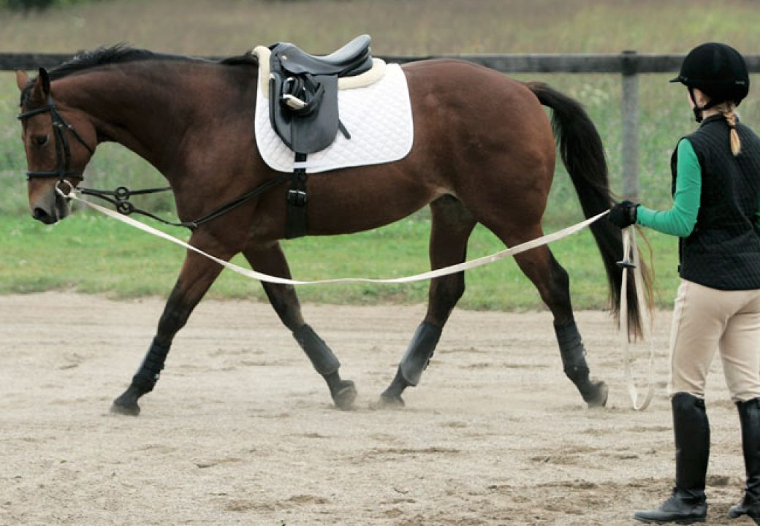
- Can you describe two different ways to safely attach a longe line to a regular snaffle bridle like the one pictured above?

- How can you tell if a horse is displaying…
Free forward movement
Regular rhythm
Acceptance of aids
Lateral suppleness
Longitudinal suppleness

