Topic | Land Conservation
D1 | Name 2 different places in your area where you see horse activities taking place. Name the facility where your meetings are often held.
D2 | Talk with grandparents, parents, instructors, and/or older friends/neighbors about where they rode when they were young, and if those places are available to ride on today. Discuss this information with Examiner.
D3 | Name 5 important rules when riding across privately or publicly owned land. Write thank-you notes to 2 land-owners who support your club to tell them why you appreciate being able to use their land. If you ride on public land, write a thank-you note to the manager or contact person.
C1 | Name 2 different locations near you where the land is used for 3 different activities, including horseback riding.
C2 | Discuss what public land is available to ride on in your county. Describe 2 things you can do to be a good steward for public land used for recreation.
HB | Provide a written description of the land conservation project and discuss why it is needed. Bring a letter from your DC verifying that the project was completed and how it has improved a facility or public space.
HA | Discuss land conservation concerns or initiatives and equine sports/horse management. Describe methods to include land conservation awareness in unmounted curriculum. Discuss the impact of land conservation issues related to your barn plan.

Name: __________________________

- Here is a map of our area. Each pin point is a location where horseback riding is allowed. When you get home, google a few of these facilities (ask first if you need permission to go online) and try to find out what you can do there. See if you can find the location of our Pony Club meetings.

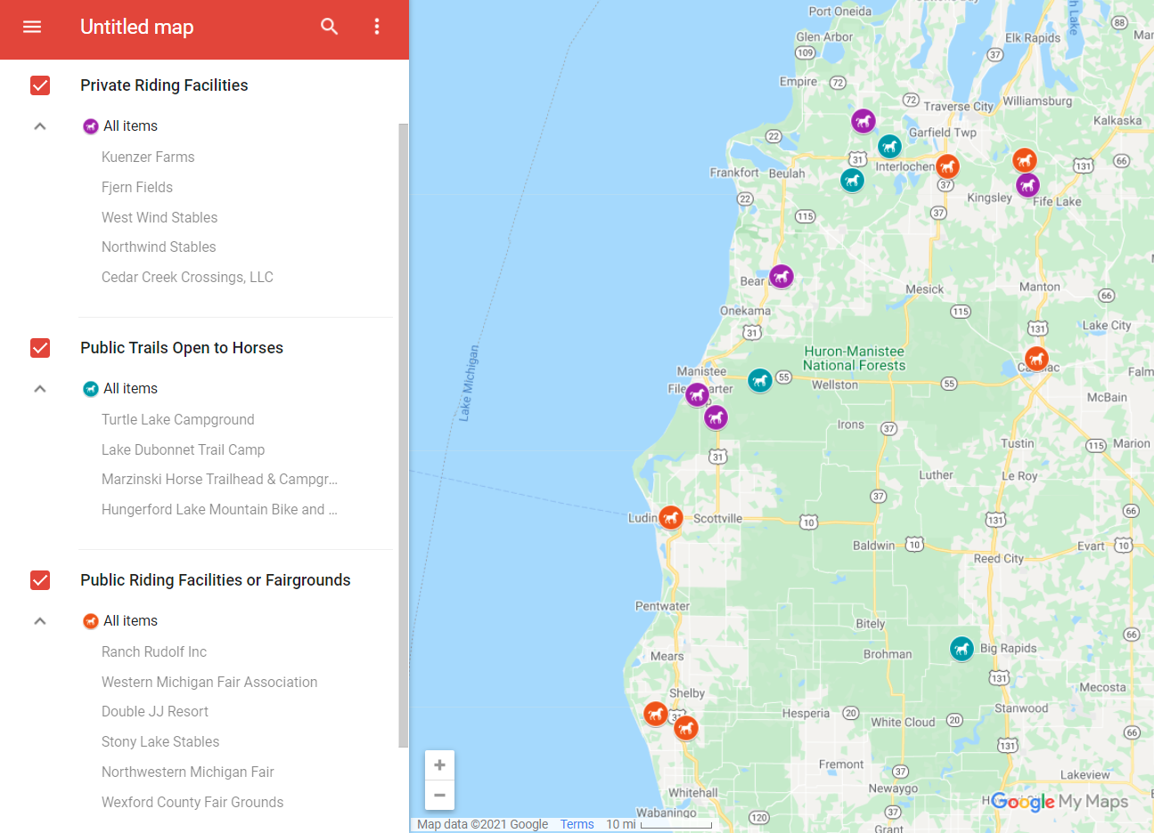

- Fill out the table below based on what you imagine riding horses was like when your grand parents or great-grandparents were your age.
What could you do with horses when you were younger? | Your Yes/No Guess | Ask someone who is at least 60 years old about their experience and write down their answers. | And now?
Could ride to school?
Could ride to the store?
Could ride on the neighbor’s land?
Could ride on the beach?
Could show at fairgrounds?
How common were horses when you were younger?
Could keep a horse in town?
Could easily visit barns in the area?
Could see horses out my window?
Friends with other kids who rode?
Had other family members rode?
Both boys and girls rode horses?
What type of riding did you do when you were younger?
Took formal riding lessons?
Rode horses in competitions?
Got to ride indoors in the winter?
Rode Western?
Rode English?
Rode Bareback?
Trailered a horse across state lines?

- Write down 3 ways you can personally help improve the facility where you ride. Then work with another pony club member to pick one of those improvement projects, make a plan together, and do it.
  - Project 1: ____________________________________________________________________________
  - Project 2: ____________________________________________________________________________
  - Project 3: ____________________________________________________________________________
The Plan
Start Date: __________________ Finish Target Date: __________________
Materials needed: | People needed: | Skills needed:
Steps:

