Horse Boots | Picture | What are they for?
Shipping Boots | 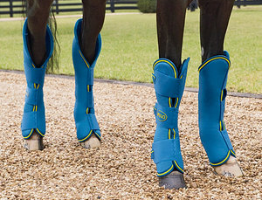 | Shipping boots offer protection against scrapes and bumps for the entire lower leg while traveling. They often extend to cover the hock and knee and are low enough to protect the heel bulbs and coronary band. Unlike shipping bandages, they do not provide support nor will they keep a horse’s leg from swelling or stocking-up.
Fly Boots | 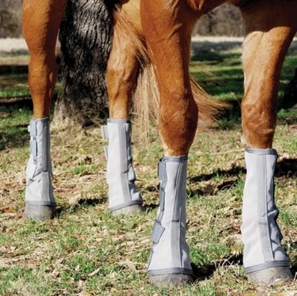 | Protect the lower legs from biting insects. Made from a stiff mesh material. Usually fastens with Velcro. Typically worn as a set of 4.
Bell Boots | 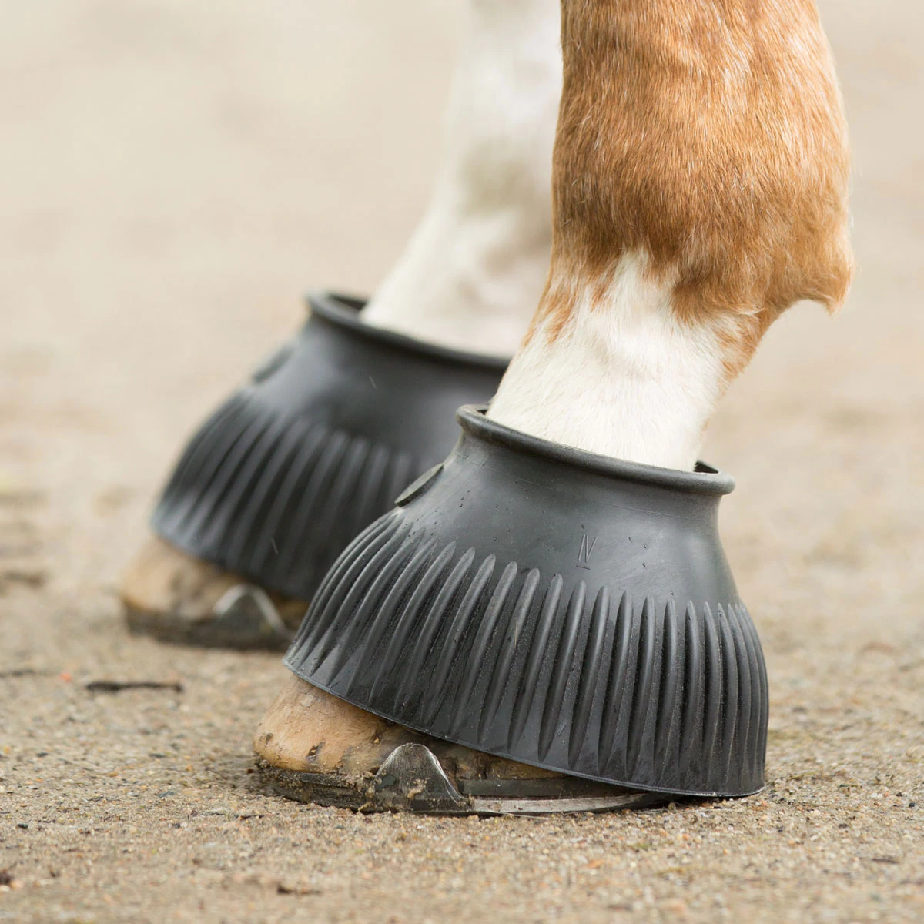 | Protects the heel bulbs and coronary band from injury. Often used on all 4 feet when trailering or on the front feet when riding or during turnout. May help keep shoes if a horse tends to pull shoes by stepping on the heels. Can be pull-on or have fastening straps. Often made of rubber or neoprene.
Cross Country Boots | 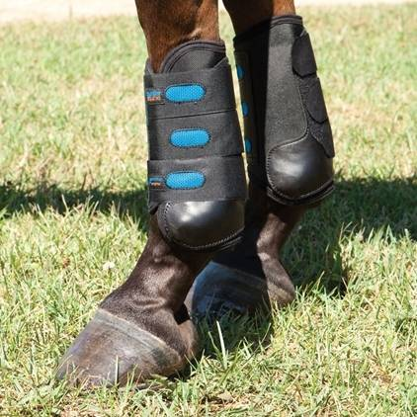 | Protects the lower legs from interference and bumps caused by the cross country course. They are typically light-weight and maybe made of mesh, neoprene, or other non-absorbent material. The strike plate usually wraps around the back of the leg to protect tendons and ligaments. The boot offers protection all the way around the cannon bone unlike other styles of jumping boot. Often have Velcro fasteners. May be worn on all four legs, but front and hind boots are shaped slightly differently.
Fetlock Boots or Ankle Boots | 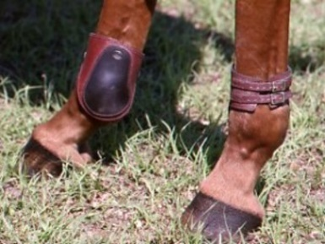 | Protects the inside of the legs (specifically the fetlock joint) from interference. Maybe leather, neoprene, or other material. The protection plate is usually a stiffer material. Often have Velcro fasteners. Typically worn on the hind legs.
Skid Boots | 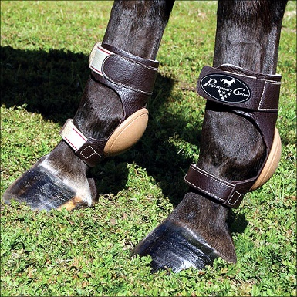 | Used in the sport of reining and other Western disciplines, these boots protect the horse’s hind fetlock joints when performing a sliding stop. They can be used on their own or over the top of polo wraps.
Horse Boots | Picture | What are they for?
Splint Boots or Brushing Boots | 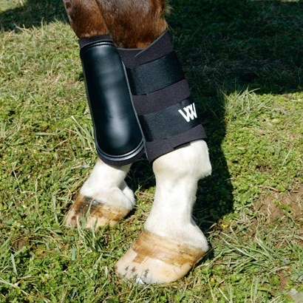 | Protects the inside of the legs (from the splint bones down to the fetlock joint) from interference. The strike plate on these boots come in different shapes and stiffnesses, so choose the one that fits your horse best. Maybe made of leather, neoprene, fleece, or other material. If worn for cross country, use a material that will not absorb water. Often have Velcro fasteners. May be worn on all four legs or in front/hind pairs.
Open-Front Boots | 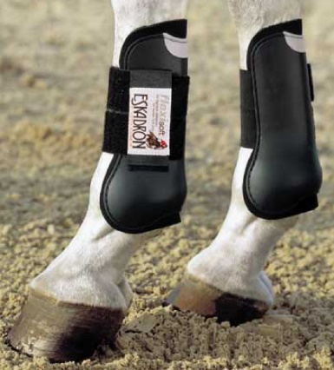 | Often used in jumping on the front legs to protect the tendons and ligaments that run behind the cannon bone and fetlock joint from being damaged by the horse’s back hooves. The open front design still allows the horse to feel if they knock a rail. The strike plate wraps around the back of the leg and is made of a hardened material like Kevlar or TPE. Usually lined with a cushioned material like neoprene or fleece. Even though they are typically only worn on the front legs, they may be sold with a matching pair of fetlock boots for hind legs.
Sports Medicine Boots | 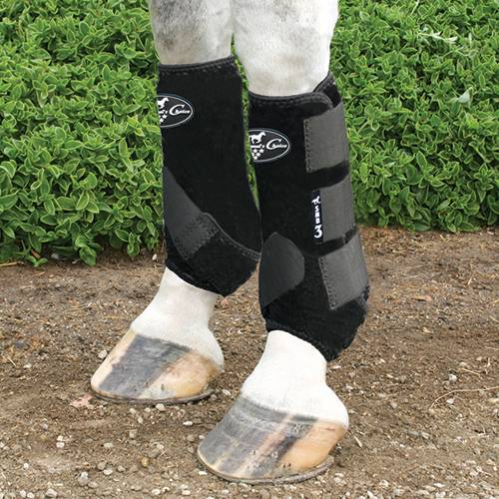 | Often used as an alternative to polo wraps. This boot is made of neoprene with Velcro fasteners. The boots provide some protection from interference and mild support of the suspensory ligament. May be worn on all 4 feet or in front/hind pairs.
Ice Boots | 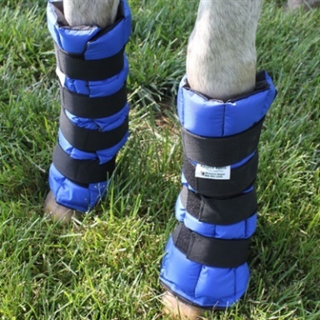 | Used to provide cold-therapy to a horse’s legs. These boots should not be used while riding or for turnout. There are many different styles of these boots that are designed to fit different areas of the leg, typically knee, hock, and lower leg. They do not need to be used in pairs. Keep the boots in a freezer just like you would keep an icepack. Follow common sense and veterinary advice for use. Do not ice for longer than 15 minutes at a time.
Soaking Boots | 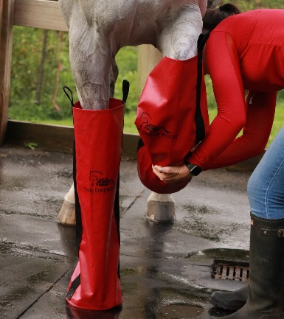 | Another option to utilize cold-therapy. These boots can be filled with water, ice water, Epsom salt mixtures, and various soaking medicines. They should only be used while the horse is under close supervision. If applying cold or medicinal therapy follow the advice of a veterinarian. Do not ice for longer than 15 minutes at a time. There are some soaking boots that are much shorter and designed to be used to soak the hoof easier.

Bandages | Picture | Supplies | What are they for?
Polo Wrap | 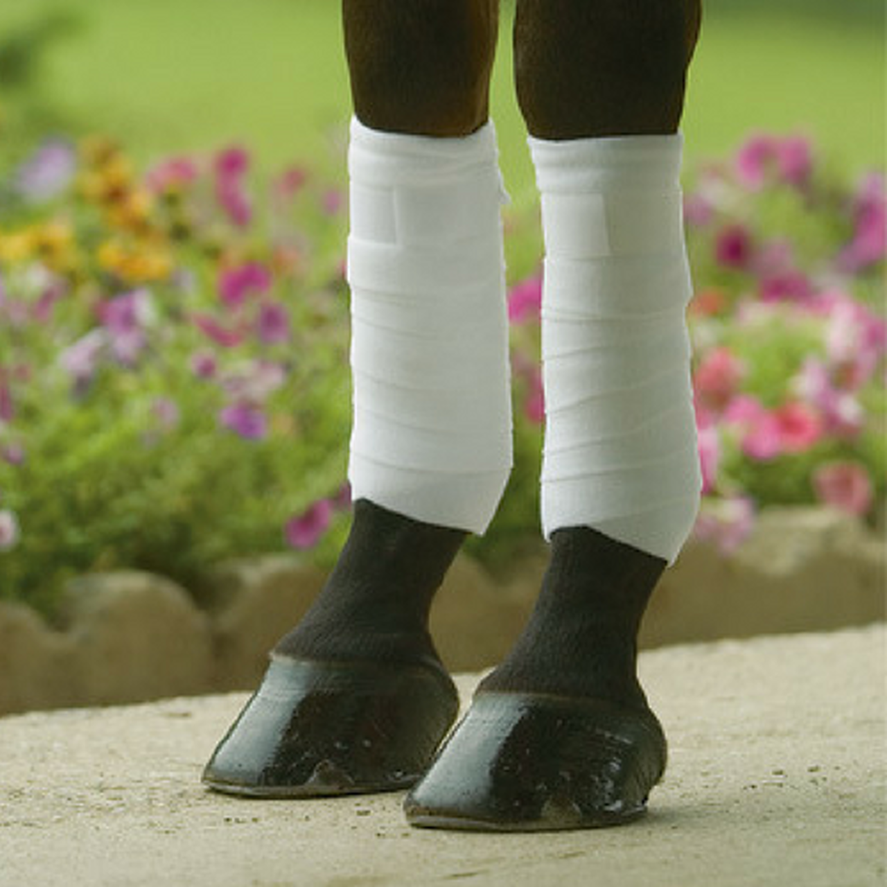 | Fleece polo wraps are soft and slightly stretchy. They typically have a Velcro closure and the width and length of the wrap should be sized to fit your horse or pony. | Mild protection from interference. Can be used on all 4 legs. Typically used while schooling, but may be used during competition if rules allow. Never use during cross country. Always wrap from the inside across the front of the cannon bone to the outside. Only tension the wrap over the cannon bone. Do not tighten the wrap over the tendons.
Stable Bandage | 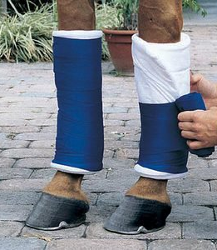 | Use track bandages or flannel bandages. These are thin and not as stretchy. Do not use polo wraps. Ensure your quilting has enough thickness to prevent tendon injury. A USPC approved brand is Wilker’s or you can make your own. The length of the quilt should be from just below the knee/hock to just below the fetlock joint. | Gives protection, support, and warmth to the lower leg. Prevents stocking up if a horse must stand in a stall after a hard ride. Can be used as the base of support for many other types of bandages to treat injuries. Always wrap in front/hind pairs. There should be a small amount of quilted padding at the top and bottom of the bandage.
Shipping Bandage |  | Use track bandages or flannel bandages. You may need to make your own to ensure they are long enough. Ensure your quilting has enough thickness to prevent tendon injury. Because of the height needed, you’ll often need to make your own. The length of the quilt should be from just below the knee/hock to the ground. | Gives protection, support, and warmth to the lower leg including the coronary band and heel bulbs. Prevents stocking up if traveling a long distance in a trailer. Also protects from bumps and scrapes while traveling. Apply to all four legs. There should be a small amount of quilted padding at the top of the bandage. The bottom of the bandage should extend under the heel bulbs and across the hoof.
First-Aid Pressure Bandage | 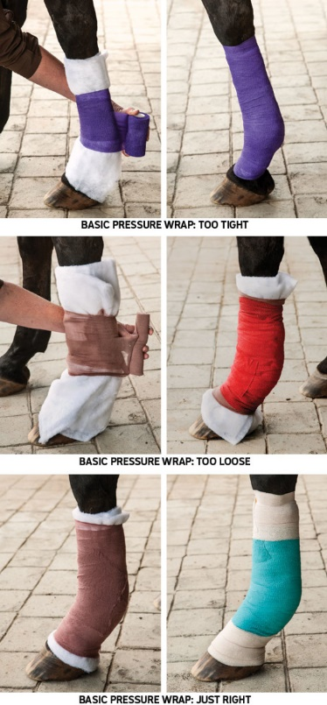 | Use a sterile gauze pad and then place 2-3 layers of absorbent cotton over it. On top of the cotton, use stiffer 6” brown gauze and then vet wrap. Finally add athletic tape to the top and bottom of the bandage. | Pressure bandages are used to stop bleeding and keep an injury clean while it is healing. They often need to be changed daily, and should be used at the direction of a veterinarian. If this bandage is applied incorrectly, you can do severe damage to the lower leg. The wrap should be smooth and snug but not so tight that it could cause damage to tendons or cut off circulation.
Let’s learn about horse boots and bandages

What type of boots or bandages do you personally use when you ride?

What type of boots or bandages have you seen riders use and what riding discipline were they doing?

What boots or bandages might be appropriate when you travel with your horse?

What types of boots or bandages might be useful to help a horse heal from a minor injury?

What could go wrong if you put a boot on incorrectly?

What could go wrong if you put a bandage on incorrectly?

What type of boots are safe to use while your horse is turned out?

