Pony Club – Learn from a Farrier

Get to know your farrier. What is your farrier’s name? _____________________ phone number? ____________ Observe a horse being trimmed and ask your farrier some questions while he/she works.

- Identify the parts of the hoof on your paper.

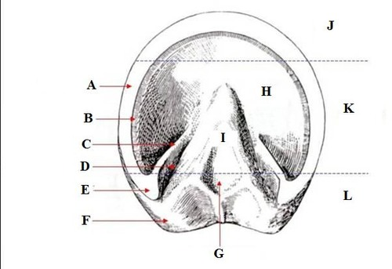

N

M

Apex of the Frog
Bars
Bulbs of the Heel
Central Cleft of the Frog or Central Sulcus
Collateral Grove
Frog
Heel
Heel Buttress
Outer Wall or Periople
Quarter
Sole
Toe
Water Line or Corium of the Wall
White Line or Laminae of the Wall

- Ask the farrier to show you the parts on a real hoof.

- Name each farrier tool. If you’re not sure, ask your farrier to help you identify them.
- Circle the ones he/she uses for a barefoot trim. Mark a star next to the tools used if your horse wears shoes.
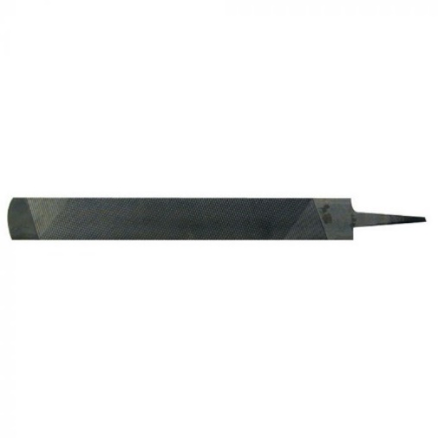 | 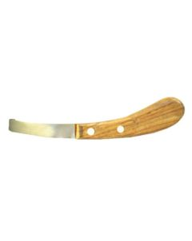 | 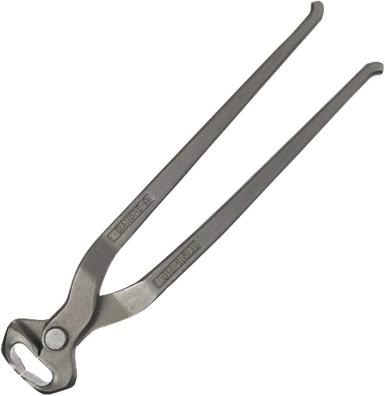
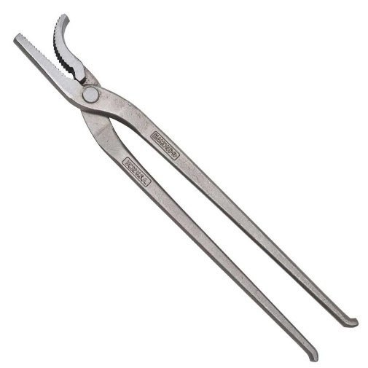 | 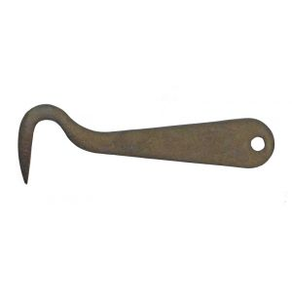 | 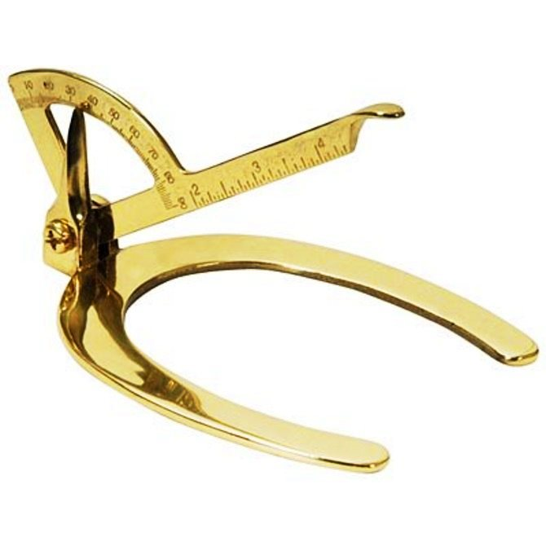
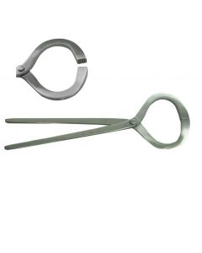 | 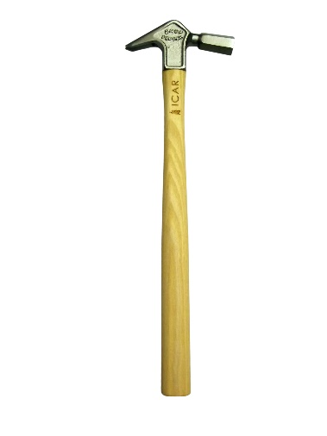 | 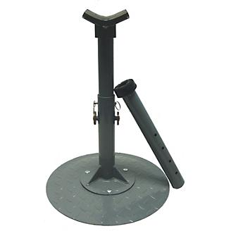
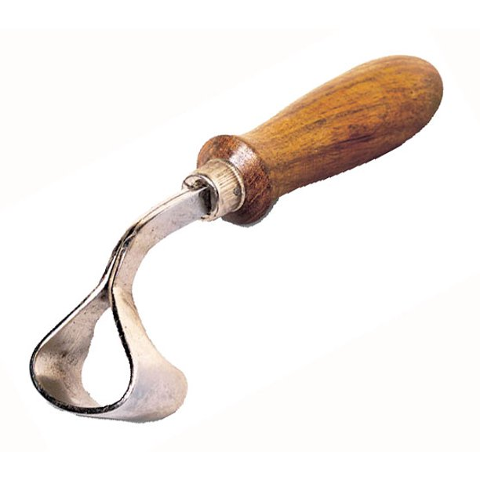 | 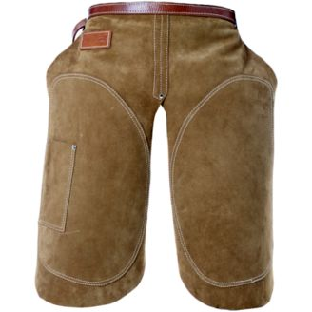 | 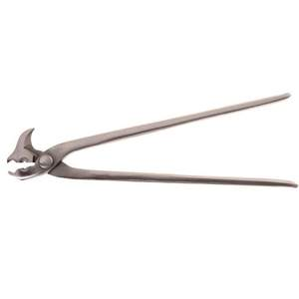
Rasp, Hoof Knife, Hoof Tester, Oval Knife, Hoof Stand, Apron, Hammer, Hoof Pick, Nippers, Shoe/Nail Puller, Clincher, Hoof Guage
Can you learn the answers to the following questions by interviewing your farrier?

- How long has your farrier been trimming horses hooves?

- How did he/she learn to become a farrier?

- How can you tell that a horse needs his/her feet trimmed?

- What are the most important signs that the hoof has been trimmed correctly?

- When should a horse wear shoes?

- When should a horse be barefoot?

- What are the three most important things a horse owner can do to make sure their horse’s feet stay healthy?

