Topic | Conformation/Unsoundness, Breeds, Colors, and Anatomy
D1 | Name and locate 10 parts of the mount.
D2 | Name and locate 15 parts of the mount.
D3 | Name and locate 20 parts of the mount. Describe the eyes’ location and how this affects the mount’s vision. Know 1 common conformation fault for each of the following: head, neck, shoulder, back, and pasterns.
C1 | Identify and discuss 3 bad points of basic leg conformation. Name, describe, and locate on a mount 5 common unsoundnesses.
C2 | Discuss how conformation of own mount is related to its breed. Discuss angles of shoulder and hip of own mount. Name 5 basic conformation qualities that you want in a mount for your own use and how they affect basic movement and soundness. Name, describe, and locate: splint, bowed tendon, ringbone, sidebone, navicular, thoroughpin, curb, bone spavin, and bog spavin.
HB | Name and locate the inner and outer hoof structures. Discuss the functions of hoof structures. Name and locate the principal bones, tendons, and ligaments of the front leg (from the scapula down). Name and locate the principal bones, tendons, and ligaments of the hind leg (from the pelvis down). Discuss the overall balance of a mount including proportion and angles. Relate the mount’s conformation to long term soundness and athletic potential. Discuss a variety of conformation faults (front leg, high leg, and other areas of the body) and how they may affect long-term soundness. Identify and discuss conformation faults and how they might affect movement. Discuss various types of lamenesses including potential causes, location, inner structures involved and related conformation faults.
HA | Discuss all aspects of teeth/mouth. Discuss the anatomy of the leg (including principle bones, tendons, and ligaments). Discuss lameness associated with conformation faults, including uses and limitations of horses with conformation faults. Discuss functional anatomy and the biomechanics of movement.

Pre-Lesson Worksheet: Name: __________________________

- Parts of the horse
Can you identify the parts of the head?  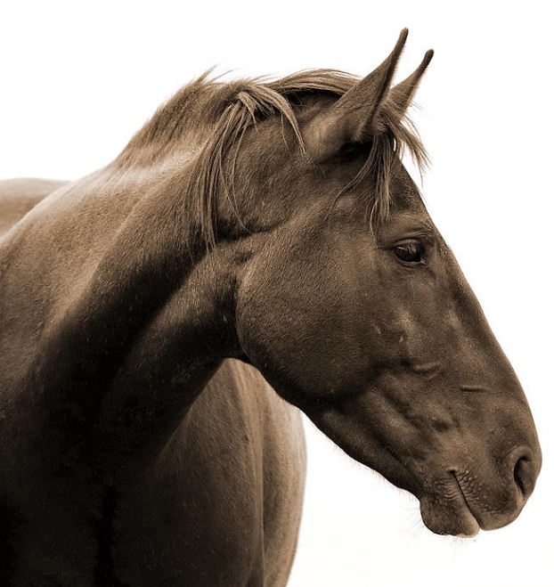 | Can you identify the parts of the hoof?  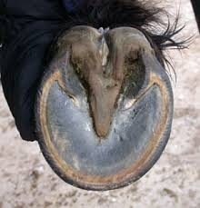

Parts of the horse continued…
Can you identify the parts of the front leg? | Can you identify the parts of the hind leg?  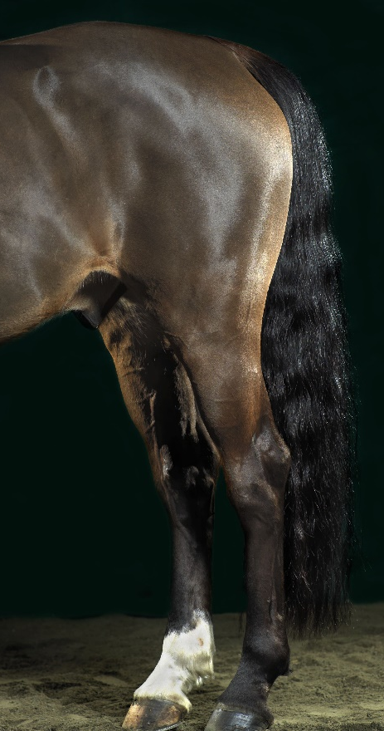
Can you name the parts that make up a horse’s topline?

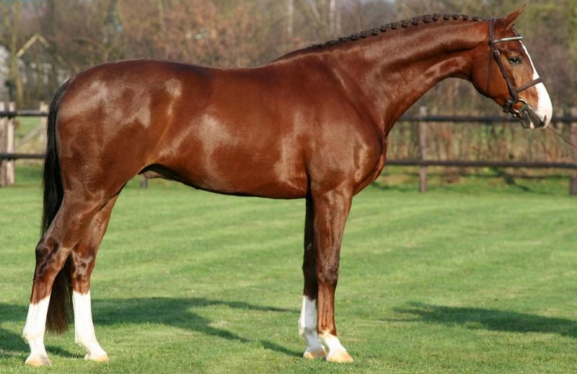

- What does conformation mean and why might it be important?

- Draw a plumb line on the picture below to help evaluate the horse’s hind end conformation. What primary fault to you see?
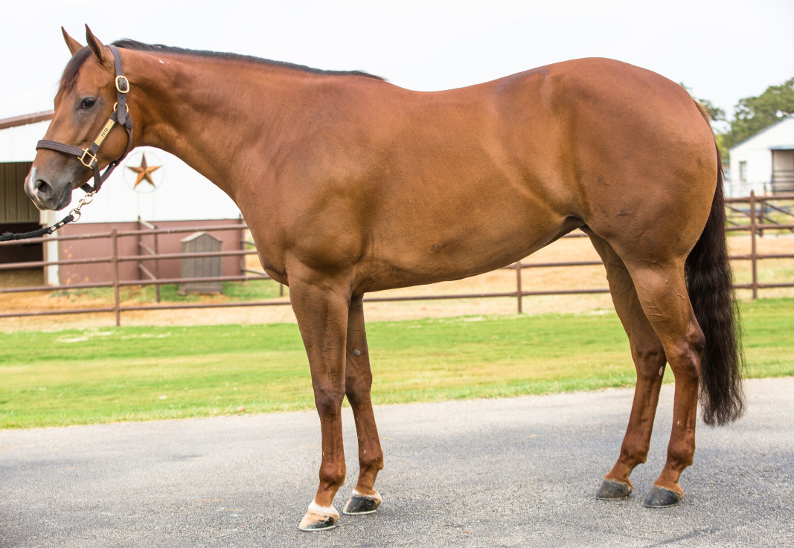

- Review the picture of the horse above. Can you determine the angle of the shoulder? Based on this angle how would you expect the horse’s gaits to feel when riding them?

- Where are the following common unsoundnesses or blemishes located on the horse?
  - Splint
  - Bowed Tendon
  - Ringbone
  - Sidebone
  - Navicular
  - Thoroughpin
  - Curb
  - Bone Spavin
  - Bog Spavin

- What is the difference between a tendon and a ligament?

- Can you identify the main bones of the front leg and the hind leg?

- How many of each different type of teeth does a horse have?
  - Incisors
  - Canines
  - Wolf Teeth
  - Premolars
  - Molars

