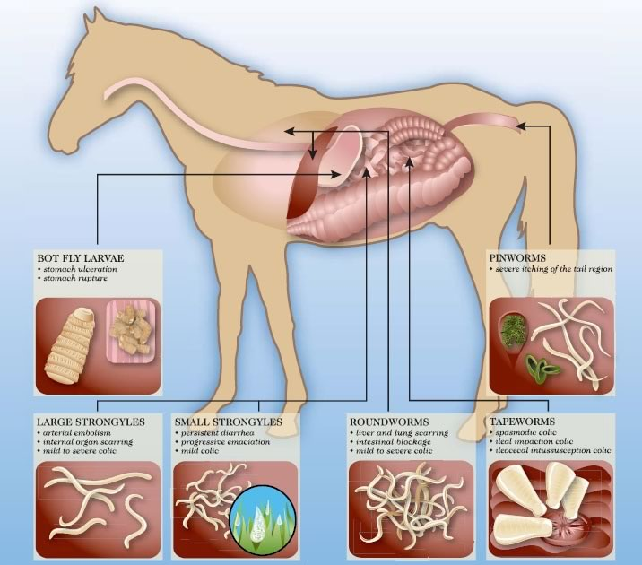
Common Equine Parasites

Each season, you should have a Fecal Egg Count done on your horse. An FEC only measures the level of ascarids and strongyles in your horse. It cannot reliably determine if bots or tape worms are present. Which is why, at a minimum, plan to de-worm in the spring after the last frost and in the fall after the first frost. At this time, use a de-wormer that will fight against bots and tapeworms in addition to strongyles and ascarids. I use Zimectrin Gold or something similar which has both ivermectin and praziquantel. It might be tempting to de-worm your horse all the time, but scientists and veterinarians have found that current parasites are developing resistance to de-worming drugs. Which means that the drugs won’t be as effective. To reduce the risk of parasites with resistance in your horse you should only de-worm when needed.

To determine if you horse has a high load of parasites and needs to be de-wormed, you or your vet should perform a Fecal Egg Count.
You look at a prepared sample of your horse’s manure under a microscope and count how many eggs you can find within a grid. This allows you to calculate the parasite level in your horse, and determine if you should de-worm. If your horse is determined to be a low shedder he probably only needs to be de-wormed in the spring and fall. If he is a medium shedder you may want to de-worm based on the FEC in the summer and winter too. If he is a high shedder, you should work with your veterinarian to determine a de-worming strategy that includes pasture management, and routine FEC’s to monitor the effectiveness of a de-worming ingredient.

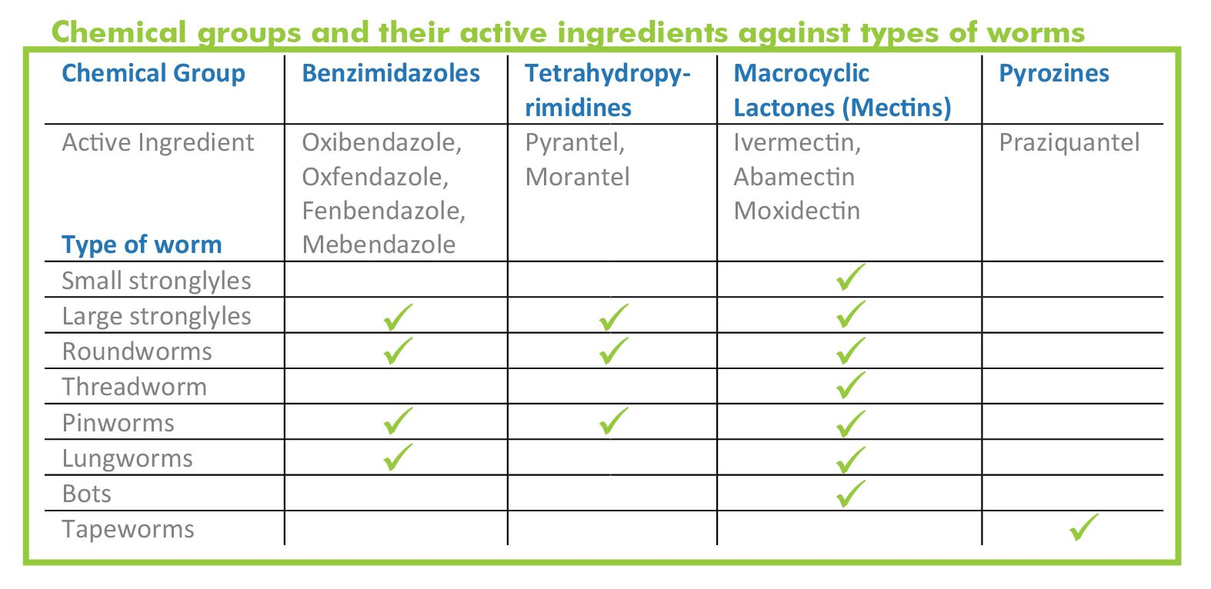

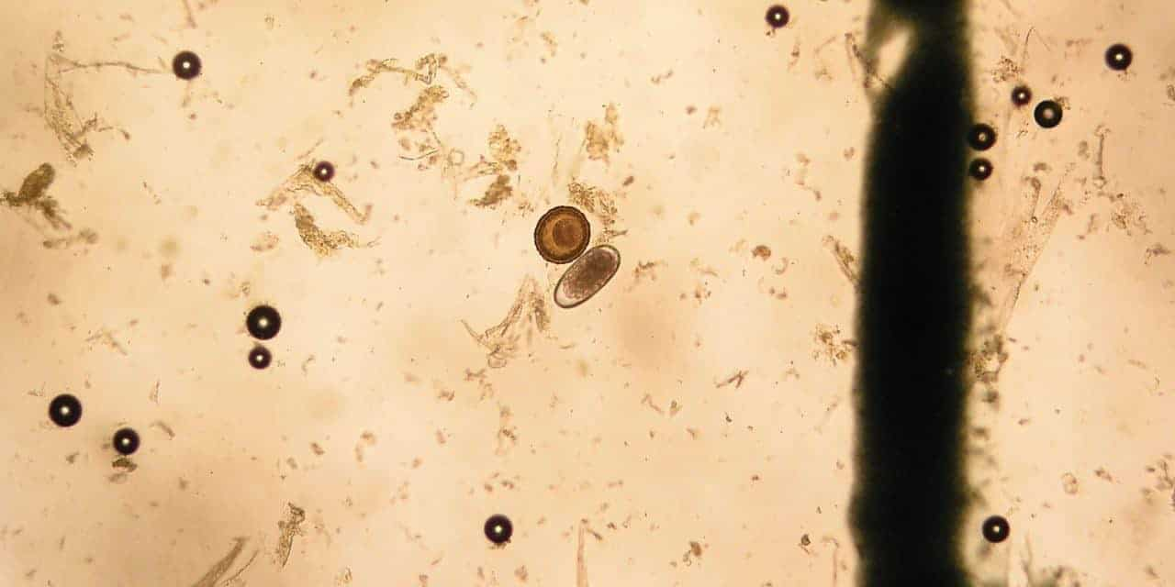
Strongyle Egg
Ascarid Egg
Air Bubble
General Debris
Ascarid (Roundworm) Egg
Strongyle Egg
A picture of what you might see under a microscope when looking for parasite eggs.

Look in the microscope and try to calculate what the FEC would be for this horse.
- Count all the eggs you can find inside the grid on both sides of the microscope slide.
- Keep track of the different type of eggs you see separately.
- Be careful not to double count or skip any.
- Only count actual eggs, don’t count bubbles or debris.
- Multiply your number by 4 to get the eggs per gram result.
  - Low Shedder = less than 200 eggs per gram
  - Medium Shedder = 200 – 500 eggs per gram
  - High Shedder = more than 500 eggs per gram
- Compare your result with your fellow club members.
Pasture management

The control of internal parasite of the horse is based on cleanliness, management, and deworming drug treatment. Appropriate removal of manure from stalls and pastures is paramount to parasite management. In small pastures (less than 3 acres) manure should be removed from the paddock at least twice a week and placed in a compost pile. The larvae in composted manure will be destroyed if sufficient heat is built up. In large pastures frequent mowing, chain harrowing (dragging), and rotation of pastures along with separating age classes of horses and avoiding overcrowding should be practiced.

Manure Management: Mowing and spreading manure by dragging pastures will decrease incidence of infective larvae if the climate allows for drying of manure. Try to drag the pastures in the morning and on hot sunny days to allow a full day of drying. Vacuuming or collecting manure in pasture is expensive, but it can be very effective.

Grouping horses in pastures according to age: This will help minimize young horses coming in contact with heavy larval infestations. For example, pasture mares and foals away from other horses less than 2 years of age. Yearling horses often need a different control program than a broodmare. It can be more difficult to control parasites in a herd if all ages and classes of horses are in a pasture together.

Pasture Rotation: Horses should be removed from pastures for a minimum of 6 to 8 weeks in pasture rotation. Where possible, add sheep or cattle to your rotation to cut down on parasite numbers. Alternative grazing with ruminants and pasture rotation schemes will aid in disrupting the parasite life cycle. Grazing ruminants in rotation with horses will reduce parasite infestation, because most internal parasites are host specific. Pasture rotation may also help by decreasing incidence of overgrazing, thus decreasing ingestion of parasites.

Feeding: Always feed out of tubs and put hay in racks of hay feeder to avoid contamination with manure.

Introducing new horses: New or transient horses should be kept separate from existing horses until parasite burden is assessed.

