Topic | Breeds & Colors
D1 | Name color and breed of own mount.
D2 | Name and describe 6 colors of mounts. Name and describe 5 markings a mount might have. Name 5 breeds.
D3 | Name 5 ways any mount could be identified. Name 10 equine breeds.
C1 | N/A
C2 | Discuss how conformation of own mount is related to its breed.
HB | N/A
HA | N/A

Pre-Lesson Worksheet: Name: __________________________
- Name color and breed of own mount.

- Name as many breeds as you can.
1. | 7.
2. | 8.
3. | 9.
4. | 10.
5. | 11.
6. | 12.

- Write down 6 colors. Describe each color to a partner (take turns going back and forth).
1. | 4.
2. | 5.
3. | 6.

- Write down 6 markings. Describe each marking to a partner (take turns going back and forth).
1. | 4.
2. | 5.
3. | 6.

- How can you tell one horse apart from another?

- How are horses identified at a rally?

- How does your horse’s conformation and attitude compare to its typical breed features?

Instructions:
- Use a dry erase marker to draw either a face marking, a leg marking, a coat pattern, or an identifying mark.
- Trade with a partner to see if you can figure out what the other person drew.
- Can your partner figure out what you drew?

Face Markings
Star (spot on forehead)
Strip/Stripe (thin stripe down the face)
Blaze (thicker stripe down the face)
Snip (spot of muzzle)
Bald Face (white that extends to the eyes and down along the cheeks)
Combinations of markings

Leg Markings
Coronet (thin white marking just above the hoof)
Heel (only white over the heel bulbs)
Half Pastern (white ½ way up the pastern)
Pastern (no white over the fetlock joint)
Sock (at least some white over the fetlock joint)
Half Cannon (white ½ way up the cannon bone)
Stocking (at least some white touching the knee or hock)
Ermine Spots (dark spots along the coronet, often seen with striped hooves)
Zebra stripes AKA leg barring (horizontal stripes near the upper parts of the leg)

Coat Patterns
Tobiano (white crosses the back between withers and tail)
Overo AKA Frame Overo (white does not cross the back between withers and tail)
Sabino (white legs and some roaning)
Splashed White (white only on legs and under stomach)
Tovero AKA Medicine Hat (mostly white with splashed of color)
Rabicano (looks like roaning on the flank or belly of the horse)
Piebald (black and white)
Skewbald (any other color and white)
Blanket (white over rump with spots)
Snowcap (white over rump with no spots)
Leopard (white with large colored spots)
Snowflake (colored horse with small white spots)
Frost (roan blanket, can be along the neck, withers, and rump)
Varnish Roan (similar to a roan but also with some leopard spots, usually lightens to more grey over time)
Dappled (darker rings within the coat)
Seal (lighter colored under belly, neck, and muzzle)
Brindle (subtle vertical stripes along barrel)
Dorsal stripe (Darker colored stripe along the horses topline – commonly seen in duns)
Shoulder shadow (darker area across the withers)

Other identifying features
Brand (often on side of rump or neck)
Tattoo (often on the inside of the lip)
Scars (shows up as white hair or bald area)

Instructions:
- Create a breed bingo card using the breeds listed below.
- Take turn drawing a breed card.
- Read the breed description and look at the picture.
- If you can identify the breed and you have it on your bingo sheet, mark it.
- If you get a line shout BINGO.

Pony Breeds
Cleveland Bay
Connemara
Exmoor Pony
Fell Pony
German Riding Pony
Hackney Pony
New Forest Pony
Pony of America (POA)
Quarter Pony
Shetland Pony
Welsh Cob
Welsh Pony

Gaited Horses
Icelandic
Missouri Fox Trotter
Paso Fino
Peruvian Paso
Rocky Mountain Horse
Tennessee Walking Horse

Typical Horses
Akhal-Teke
Andalusian (PRE)
Anglo-Arabian
Appaloosa
Appendix Quarter Horse
Arabian
Quarab
Barb
Brumby
Bashkir Curly
Lipizzan
Lusitano
Marwari
Morgan
Mustang
Paint
Quarter Horse
Saddlebred
Standardbred
Thoroughbred

Warmbloods
Dutch Warmblood (KWPN)
Freisian
Hanoverian
Holsteiner
Irish Draught
Oldenburg
Trakehner
Westphalian

Large Draft Breeds
Belgian
Brabbant
Clydesdale
Percheron
Shire

Small Draft Breeds
Gypsy Vanner
Haflinger
Norwegian Fjord

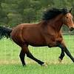  Cleveland Bay | 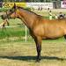  Connemara | 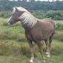  New Forest Pony
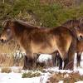  Exmoor Pony | 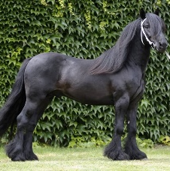  Fell Pony | 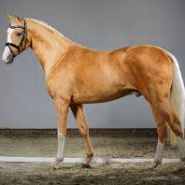  German Riding Pony
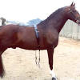  Hackney Pony | 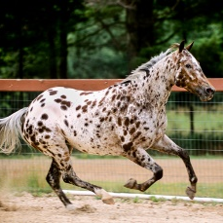  Pony of America (POA) | 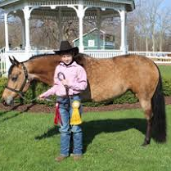  Quarter Pony
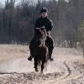  Shetland Pony | 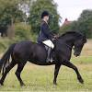  Welsh Cob | 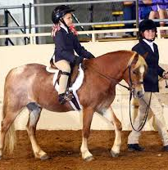  Welsh Pony
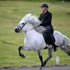  Icelandic | 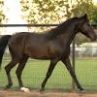  Missouri Fox Trotter | 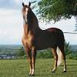  Paso Fino
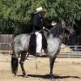  Peruvian Paso | 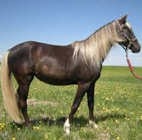  Rocky Mountain Horse | 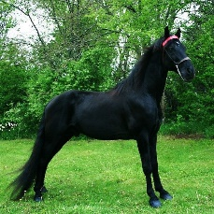  Tennessee Walking Horse
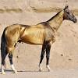  Akhal-Teke | 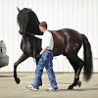  Andalusian (PRE) | 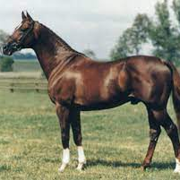  Anglo-Arabian
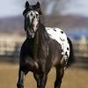  Appaloosa | 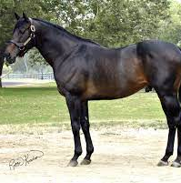  Appendix Quarter Horse | 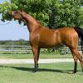  Arabian
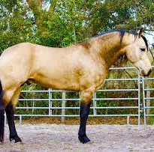  Quarab | 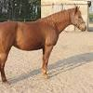  Barb | 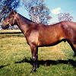  Brumby

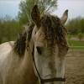  Bashkir Curly |  | 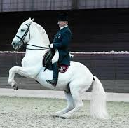  Lipizzaner |  |  | 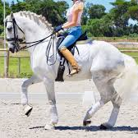  Lusitano
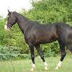  Marwari |  | 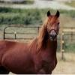  Morgan |  |  | 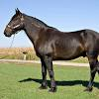  Mustang
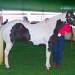  Paint |  | 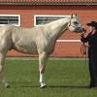  Quarter Horse |  |  | 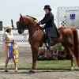  Saddlebred
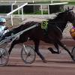  Standardbred |  | 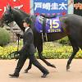  Thoroughbred |  |  | 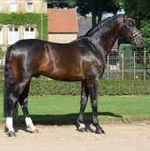  Westphalian
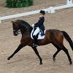  Dutch Warmblood (KWPN) |  | 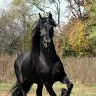  Freisian |  |  | 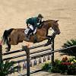  Hanoverian
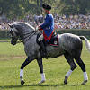  Holsteiner |  | 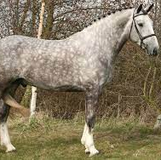  Irish Draught |  |  | 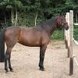  Oldenburg
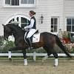  Trakehner |  | 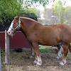  Belgian |  |  | 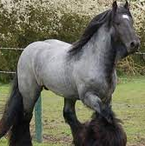  Brabbant
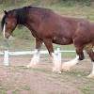  Clydesdale |  | 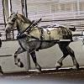  Percheron |  |  | 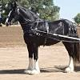  Shire
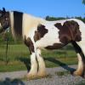  Gypsy Vanner |  | 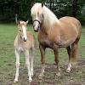  Haflinger |  |  | 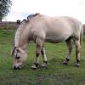  Norwegian Fjord
 |  |  | 