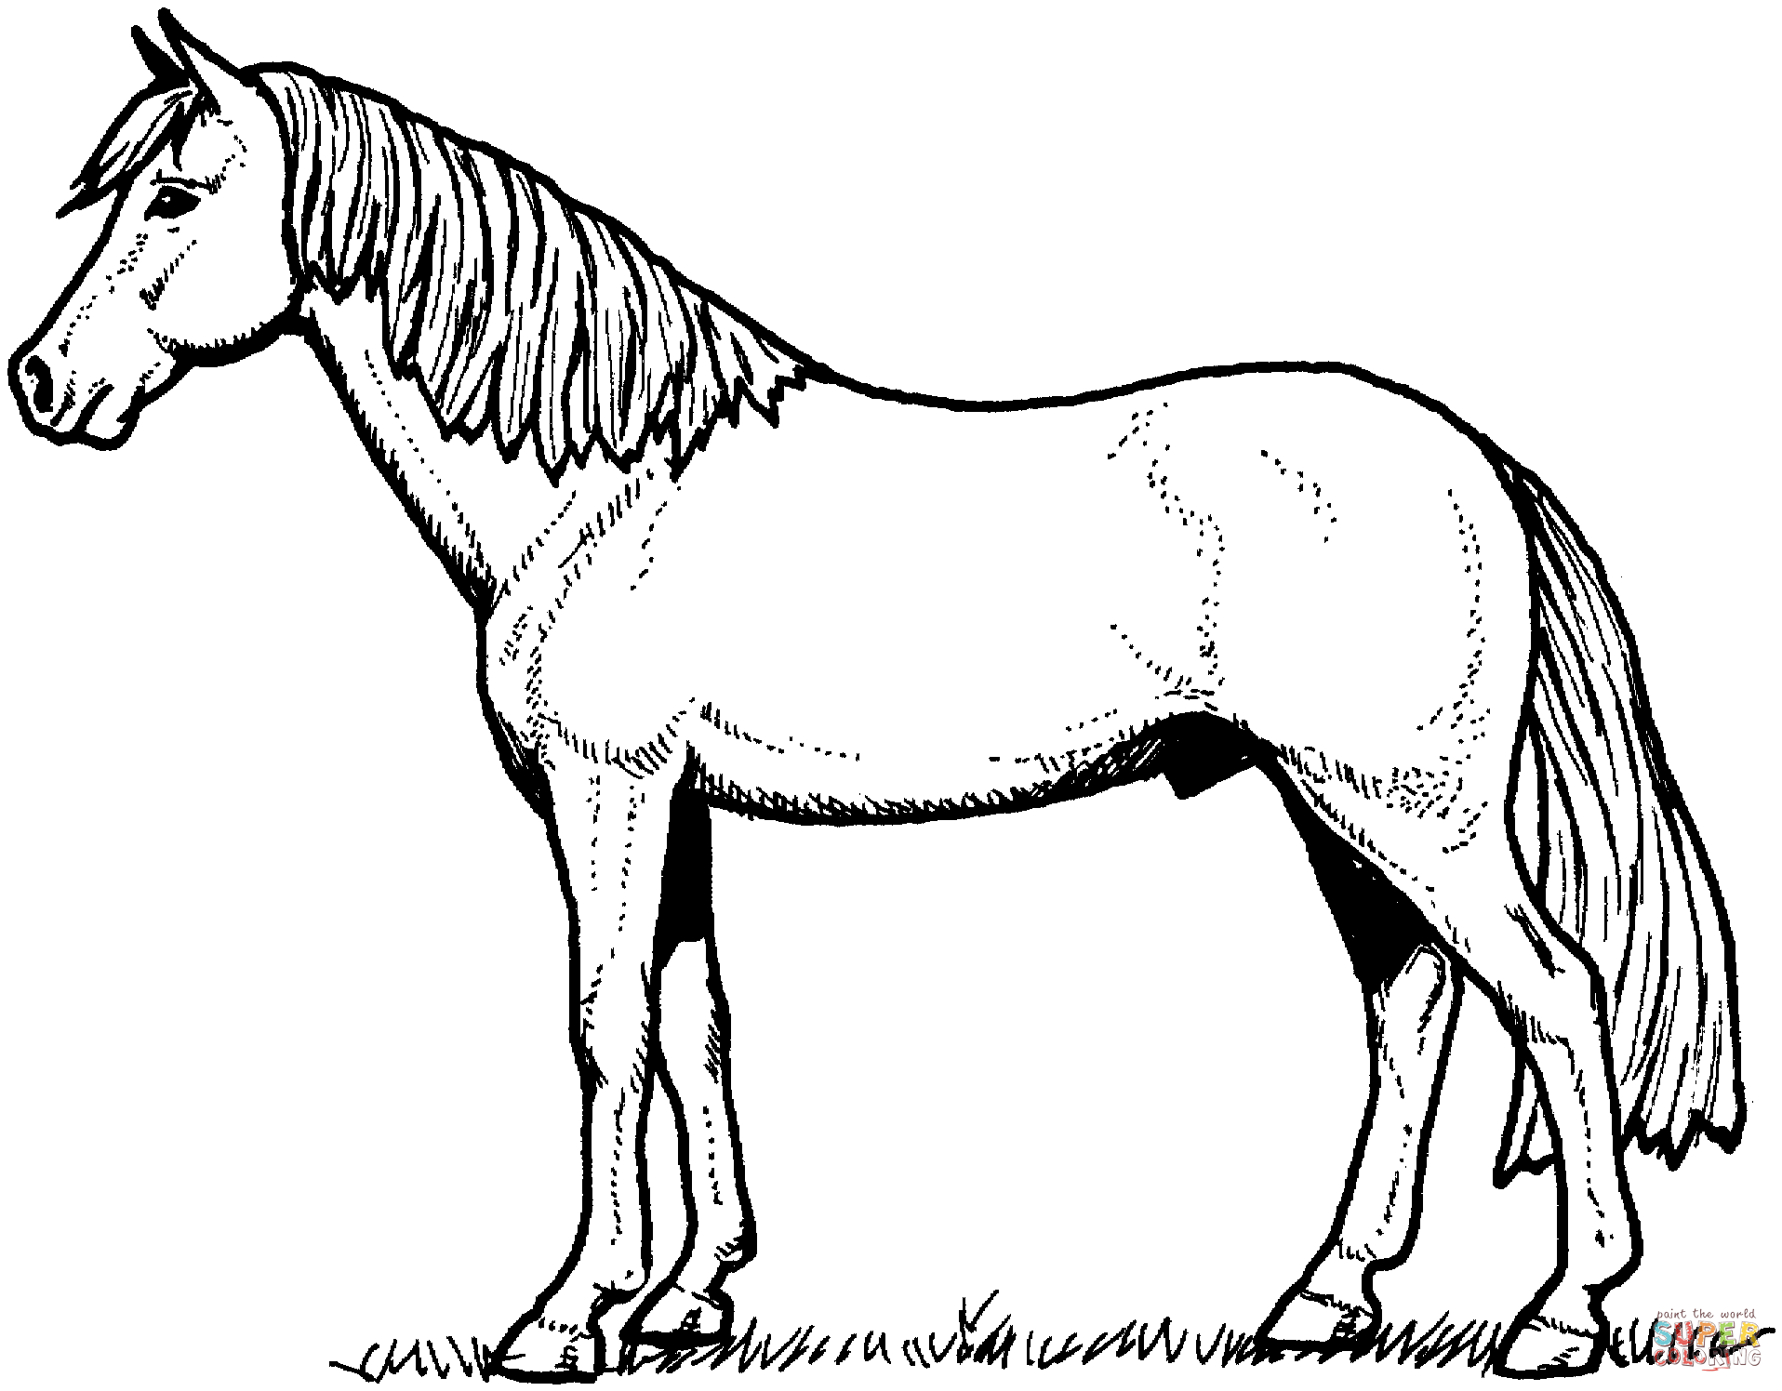
Color/Marking Bingo

Dun
Buckskin
Tobiano
Overo
Bay
Black
Blue Roan
Red Roan
Honey Roan
Strawberry Roan
Blanket Appaloosa
Snowflake Appaloosa
Dapple Grey
Cremello
Palomino
Piebald
Skewbald
Leopard Appaloosa
Chestnut
Liver Chestnut
Flea-bitten Grey
Perlino
Sabino
Grulla
Silver Bay
Chocolate Dapple
Champagne
Seal Brown
Dorsal Stripe
Zebra Markings
Stocking
Sock
Ermine Spots
Striped Hooves
Snowcap Appaloosa

